α-Synuclein Protein Preparation (Large scale) LM_01.19.2021
Adapted from: Xiao Tu, Kelvin Luk, Jonathan Branch, Patrick O’Brien, Dustin Covell, Katelyn Becker

Volpicelli-Daley, Laura A et al. “Addition of exogenous α-synuclein preformed fibrils to primary neuronal cultures to seed recruitment of endogenous α-synuclein to Lewy body and Lewy neurite-like aggregates.” Nature protocols vol. 9,9 (2014): 2135-46. doi:10.1038/nprot.2014.143

Day 1: Transformation
- Thaw E. coli (BL21(DE3)RIL) and DNA on ice
- Mix 1-2 µL DNA (α-synuclein in pRK172 plasmid) with 20µL competent cells and incubate 5-10 minutes on ice.
- Heat-shock cells for 45 s in 42°C water and place back on ice for 2 minutes.
*The microwave can be used to heat a beaker of water to 42°C.
- Add 200 µL LB (no antibiotics) and shake at 37°C for 1 hour. Warm Amp¹⁰⁰ plate @37°C.
- Plate 200 µL on agar bacteria plate with ampicillin and spread with glass cell spreader.
- Incubate the plate inverted at 37°C overnight.

- Make 4 L of TB and 400 mL of 10x phosphate buffer.
- Add 450 mL of TB + 50 mL 10x phosphate buffer into 8x 2 L flasks. Add 200 mL to a 1L flask. Cover the tops with foil, and autoclave on the liquid setting.
- Make sure to let flasks cool for at least 1 hour after they have been autoclaved, or if you’re in a hurry, cool in the cold room for at least 30 minutes.

Day 2: Making Starter Culture
- Add 5 μL of 100 mg/mL Ampicillin to 5 mL SOC/TB/LB in a round bottom tube.
- Pick a colony with a 20 µL pipet tip and drop the tip into the starter culture. Swirl around to ensure the colony detaches from the pipet tip.
- Shake at 200 RPM at 37°C overnight.
- Add 0.5 mL of the starter culture to 500 mL flask of TB/phosphate buffer and allow to shake in the incubator @200 RPM for 30 minutes without antibiotic.
- After 30 minutes, add 0.5 mL ampicillin (100 mg/mL) and grow overnight at 37°C. Expression will occur without induction overnight. With such a small starter culture, the goal is for at least 24 hours growth.

Day 3: Protein Isolation
- Transfer bacteria cultures to large centrifuge bottles (provided by glassware), make sure the bottles are balanced and centrifuge for 20 minutes at 5000 xg and 4°C (rotor F10S).
    - Pour out the supernatant after each spin and keep adding more of the culture to the bottles (balanced) until all culture is centrifuged
- THIS IS THE POINT TO FREEZE THE PELLETS IF YOU ARE NOT PROCEEDING WITH THE PREP.
If so, scrape out the pellets and transfer to a labeled 50 mL conical and store at -20°C. Otherwise:
- Pour off the supernatant and carefully scrape out pellet with spatula into a 500 mL beaker. Re-suspend remaining using cold High Salt Buffer. Use 15mL of the buffer to re-suspend the pellet, pour off into the beaker, and then use 5 mL of the buffer to rinse out the bottle, about 50 mL per liter of cell culture (total after the next step).
- Break down pellets in beaker with manual agitation. Pour of 40 mL at a time into the 40 mL dounce homogenizer (2nd drawer of bench P).
- Homogenize with pestle A (>15 times), making sure that you have broken up all clumps. Repeat with remaining bacteria until all is homogenized and poured into a small plastic beaker.
    - Rinse the homogenizer with the high salt buffer 2-3 times to get the remaining clumps and cell lysate out of the homogenizer
- Heat electric deep fryer on high heat until rapid boiling, being sure to fill the pot up so that a tube rack can be submerged.
- Sonicate on ice (in a plastic or metal beaker) at 35% for 80 sec total ON time (5 sec ON, 25 sec OFF, 80) (Recall20 at 3rd floor shared cold room sonicator).
    - You will have to attach the tip to the sonicator, make sure the tip is 1-2cm from the bottom of the cup taking care not to hit/break the tip
- Transfer the homogenate to 50 mL conical tubes (~3/4 full), MAKE SURE ALL TUBES ARE BALANCED AT THIS TIME. Boil the homogenate for 20 minutes.
- Make gel filtration dialysis buffer and put in the cold room.
- Bury tubes in ice and place them in the cold room for at least 30 minutes or until they feel cold.
- Centrifuge cold lysate for 20 minutes at 11,800 xg and 4°C (rotor F21).
- OPTIONAL: Take an aliquot of the supernatant. Add 5X sample buffer and run on a 15% gel.
- Cut dialysis tubing (12-14 kD tubing) and wash in the dialysis buffer to soften the tubing.
- Pipet supernatant into the tubing, close with clamps, put the tubing in dialysis buffer and leave in cold room overnight on the stirrer (stir slowly!).
*Leave an air bubble to promote floatation of the tubing.
- If you are doing gel filtration tomorrow, prep the Akta (S.1), and start the program (defaulthome -> alpha synuclein purification -> size exclusion chromatography->no wash Size exclusion asyn purification day2) for the gel filtration column for loading tomorrow. (S.2) Lines should be set up as:
    - A1-Size Exclusion Buffer
    - A2-Sterile Distilled Water
    - B1-20% EtOH
    - B2-20% EtOH
- Clean-up: wash all beakers and tubes with bleach and water. Wash dounce homogenizer with DI water and methanol.

Day 5: Gel filtration
*Concentration and gel filtration steps can be done on separate days if the concentration takes too long. Gel filtration is done with 1-2 runs/L of cell culture and up to 3 mL of sample/run. Make sure the fraction collector has 24/run 15 mL tubes and is centered correctly. After column prep, the fraction tube should be transferred to the fraction collector arm.

- Filter the protein through a 0.22 µm filter (1000 mL filter unit due to large surface area).
- Concentrate down to 2-4 mL/L of cell culture in Amicon Ultra Centrifugal Filter devices at 4000g, 4 °C, 15 min/cycle or Sartorius Vivaspin 15R at 5,000g. This step may take you all day if you prepare a large scale of synuclein.
- Once all the protein is concentrated down to 10mL total, filter through a 0.45um syringe filter into a 50mL conical tube.
- Load the protein sample onto the column using the A1 inlet, MAX of 13mL
  - When the sample is getting close to the bottom of the red stopper, pause the Akta and add 1-2mL of buffer A into the 50mL conical so you can pull up more protein, continue the program and stop it when it is close to the bottom again. MAKE SURE YOU PULL UP NO AIR.
- Once the sample is all loaded, continue to the “next breakpoint” to start the elution
  - Manual->Execute Manual Instructions
    - Other-> Next Breakpoint->Insert->Execute
      - Select continue
        - The program should start up again
- Make 4L of Buffer A, and place in the cold room.
- Take 10 µL of the even fractions, mix with 2.5 µL 5x sample buffer run on 2 15% acrylamide gels.
- Coomassie stain (or Instant Blue) the gels and collect the clean fractions from the gel filtration, primarily avoiding the high molecular weight protein that has a similar charge to α-synuclein (E.1).
- Cut dialysis tubing (12-14 kD tubing) and wash in the dialysis buffer to soften the tubing.
- Pipette the fractions into the tubing and dialyze the fractions against Buffer A overnight
- After the elution, the program will continue automatically to wash the column, and store it in 20% EtOH.

Day 6: MonoQ Column (1)
*MonoQ Column separates by ion affinity and may need to be calibrated based on overall charge, and the ramp may need to be determined empirically. 25%B has worked for tagged proteins before, α-synuclein elute at a higher %B than tagged α-synuclein. 1-2 runs/L of cell culture and up to 20 mL of sample/run. Make sure the fraction collector has 33/run 15 mL tubes and is centered correctly. After column prep, the fraction tube should be transferred to the fraction collector arm.

- Connect the MonoQ column between ports 2A (top) and 2B (bottom) (S.1)
- Switch inputs A1, A2 and B1) and start the MonoQ program -> Henderson Lab Qtrap Protocol (S.3) Lines should be set up as:
  - A1-Buffer A
  - A2-Sterile Distilled Water
  - B1-Buffer B
  - B2-20% EtOH
- Load the sample using A1. While the sample is loading collect the flow through to test so you know you are not losing protein not sticking to the column.
  - When the sample is getting close to the bottom of the red stopper, pause the Akta and add 3mL of buffer A into the 50mL conical so you can pull up more protein, continue the program and stop it when it is close to the bottom again. MAKE SURE YOU PULL UP NO AIR
- Once the sample is loaded, continue to the “next breakpoint” to start the wash and anion exchange
- Take 10 µL the even fractions from loop 1 and 2 as they come off, mix with 2.5 µL 5x sample buffer run on 2 15% acrylamide gels. If you will run a second day of MonoQ, you can pick the fractions to keep based on the UV trace alone.
- Coomassie stain the gels and collect the clean fractions from the gel filtration, primarily avoiding proteins that are not α-synuclein (E.2). This will primarily manifest right before and right after the main peak.
- Dialyze the fractions against Buffer A (or DPBS if this is pure enough) overnight.
*to increase purity >90% a second day of MonoQ is recommended. Dialyze the selected fractions back into buffer A overnight.

Day 6: MonoQ Column (2)
- Repeat steps 2-6 above, and keep fractions based on coomassie and UV trace and dialyze into DPBS, pH 7.0 overnight.
- The primary goal is to get rid of truncated a-synuclein. This shows up as a hump on the later end of the a-synuclein peak and can be visualized as truncated forms on the coomassie-stained gel (E.3).

Day 7: Concentrate and Aliquot
- Concentrate down to approximately 2 mL of α-synuclein or molar equivalent in Amicon Ultra Centrifugal Filter devices at 4000g, 4 °C, 10 min/cycle. The concentration needs to be over the 5 mg/mL or 15 mg/mL concentration at which the protein will be aggregated. Measure the protein concentration by a BCA assay with sample dilutions of 1:10, 1:20, 1:40, 1:60, 1:80, 1:160, 1:320, 1:640, load only 10uL of each sample into the BSA assay. Take the average of the concentration estimations for which values are in the linear range of the BSA curve.
*You can expect 10-50 mg protein/L culture, depending on the construct.
- Filter the protein through a 0.22 µm filter. Since this is a small volume, the small blue syringe filters are ideal to minimize sample loss.
- Aliquot the protein into tubes with the protein type, concentration, date and initials.
- Freeze at -80°C (monomer) or proceed with aggregation (fibrils).

- For aggregation, aliquot the protein out into low binding tubes.
  - You want at least 750uL per tube, 1 mL is ideal
- Place tubes in a heated shaker at 1000RPM at 37°C for 7 days
- After 7 days, aliquot the fibrils into small aliquots to avoid freeze thaw cycles, and store in the mid/back of the -80°C freezer.
- For quality control the sedimentation assay and thioflavin T assay should be done after they fibrillization (see additional protocols)

Examples of Mouse Alpha Synuclein prep done on 12.2020

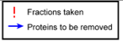
Size Exclusion Column (E.1)

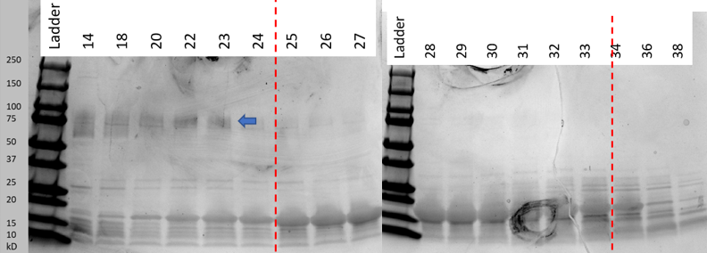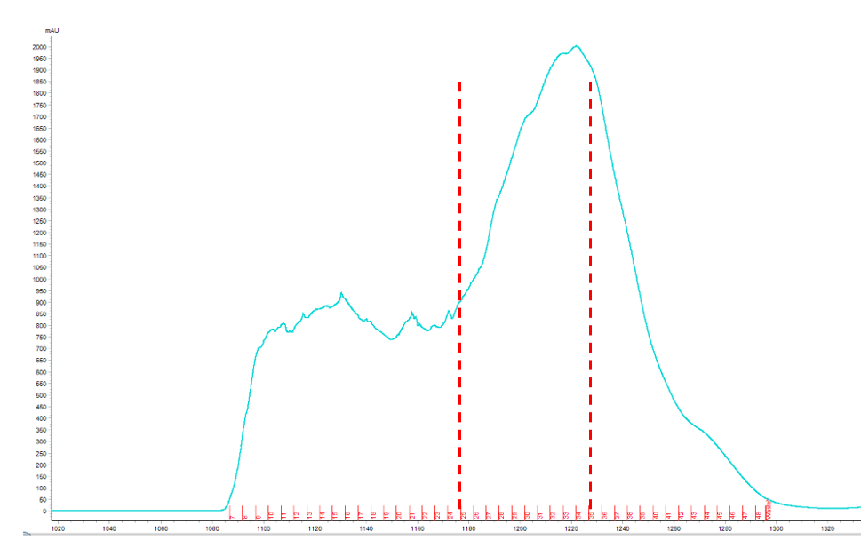


MonoQ 1 (E.2)
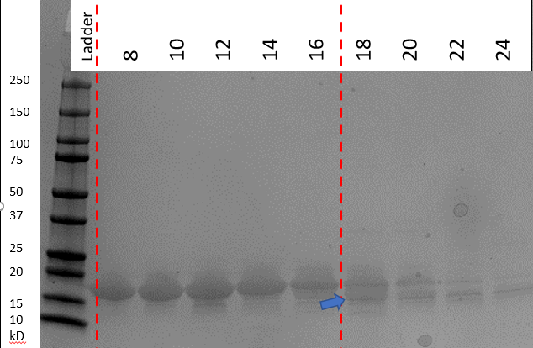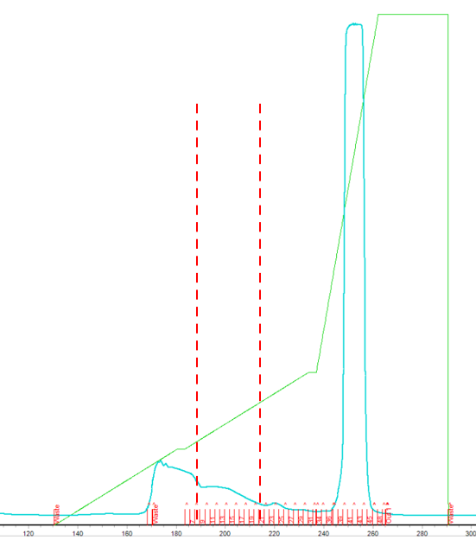

MonoQ 2 (E.3)

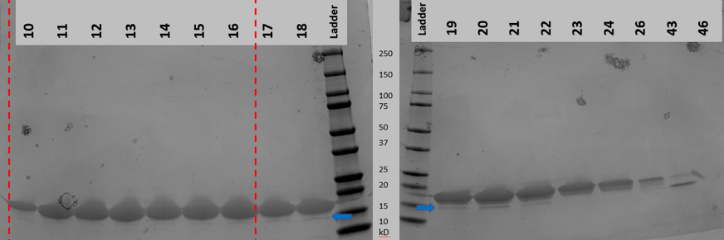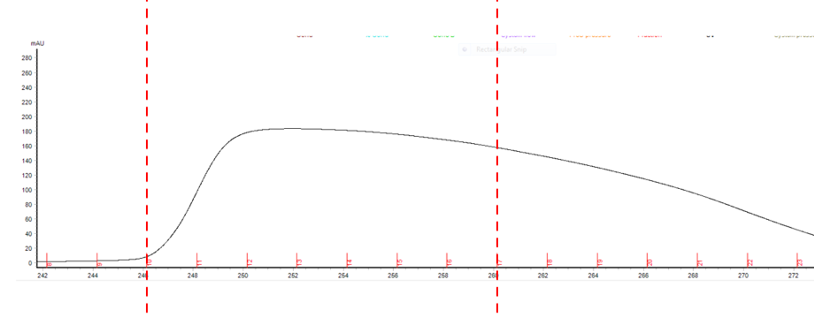

Materials
LB + 100 mg/L ampicillin (LB/Amp) plates
Competent BL21(DE3) RIL cells (Stratagene- A) (20 µL aliquots)
α-synuclein gene of interest cloned into pRK172 NdeI-HindIII site.
100mg/mL Ampicillin stock
40 mL dounce homogenizer and pestle A
Dialysis tubing (Spectrum Labs, Membrane tubing 12-14 kD)
Fisher Scientific Sonic Dismembrator Model 500 (Sonicator)
FPLC
Collection tubes
Superdex 200 Column
1000 mL 0.22 µm filter unit.
15% SDS—PAGE gels.
Amicon Ultra Centrifugal Filter devices (Amicon Ultra 15 10K MWCO)
MonoQ column (GE Health, HiTrap Q HP 645932). For truncated synucleins, another column may be necessary!
Media and solutions

Lysogeny Broth (LB)
Ingredient | Amount | Final Conc.
Bacto-tryptone | 10 g
Yeast extract | 5 g
NaCl | 10 g
MilliQ H₂O | To 1 L
Autoclave and cool before use.

Terrific Broth (TB)
Ingredient | Amount | Final Conc.
Bacto-tryptone | 48 g
Yeast extract | 96 g
Glycerol | 16 mL
MilliQ H₂O | To 4 L
10x Phosphate Buffer | Add 50 mL to 450 mL TB
Autoclave and cool before use.

10x Phosphate Buffer (PB, 1L)
Ingredient | Amount | Final Conc.
KH₂PO₄ | 23.2 g
K₂HPO₄ | 125.4 g
MilliQ H₂O | To 1 L

0.5 M IPTG
Ingredient | Amount | Final Conc.
IPTG | 120 mg | 0.5 M
MilliQ H₂O | 1 mL

High Salt Buffer (50 mL/L culture)
Ingredient | Amount | Final Conc.
5 M NaCl | 150 mL | 750 mM
0.5 M Tris, pH 7.6 | 20 mL | 10 mM
0.5 M EDTA | 2 mL | 1 mM
0.5 M PMSF | 2 mL | 1 mM
MilliQ H₂O | To 1 L
Add protease inhibitors 1:1000 and PMSF immediately prior to use.

5 M NaCl (1 L)
Ingredient | Amount | Final Conc.
Sodium Chloride | 292.2 g | 5 M
pH to 7.4
MilliQ H₂O | To 1 L

0.5 M Tris, pH 7.6 (1 L)
Ingredient | Amount | Final Conc.
Tris-base | 60.57 g | 0.5 M
HCl, pH to 7.6 | ~30 mL
MilliQ H₂O | To 1 L

0.5 M EDTA, pH 8.0 (500 mL)
Ingredient | Amount | Final Conc.
Sodium hydroxide pellets | 10 g | 0.5 M
MilliQ H₂O | 400 mL
EDTA | 96.05 g
pH to 8.0
MilliQ H₂O | To 500 mL

Gel Filtration Dialysis Buffer (1.25 L/L culture)
Ingredient | Amount | Final Conc.
5 M NaCl | 50 mL | 50 mM
0.5 M Tris, pH 7.6 | 100 mL | 10 mM
0.5 M EDTA | 10 mL | 1 mM
0.5 M PMSF | 10 mL | 1 mM
MilliQ H₂O | To 5 L
Add PMSF immediately prior to use.

Gel Filtration Buffer (1 L)
Ingredient | Amount | Final Conc.
5 M NaCl | 10 mL | 50 mM
0.5 M Tris, pH 7.6 | 20 mL | 10 mM
0.5 M EDTA | 2 mL | 1 mM
MilliQ H₂O | To 1 L

Buffer A (1L/L culture)
Ingredient | Amount | Final Conc.
5 M NaCl | 20 mL | 25 mM
0.5 M Tris, pH 7.6 | 80 mL | 10 mM
0.5 M EDTA | 8 mL | 1 mM
0.5 M PMSF | 8 mL | 1 mM
MilliQ H₂O | To 4 L
Add PMSF and filter with 0.2 µm filter (for column) immediately prior to use.

Buffer B (400 mL/L culture)
Ingredient | Amount | Final Conc.
5 M NaCl | 200 mL | 1 M
0.5 M Tris, pH 7.6 | 20 mL | 10 mM
0.5 M EDTA | 2 mL | 1 mM
0.5 M PMSF | 2 mL | 1 mM
MilliQ H₂O | To 1 L
Add PMSF and filter with 0.2 µm filter (for column) immediately prior to use.
Supplemental Information:

S.1 Preparing the AKTA Chromatography System

How to pull the lines through with the new buffer

- Place all the lines in their corresponding bottles
- Using the 25mL Syringe pull 20mLs through the lines at the correct pump location, do this slowly, if you go too quick you can introduce air into the system die to back pressure. To do this:
  - Go to Manual->Execute Manual Instructions->Flow path
    - Then you can choose Inlet A or Inlet B
      - Then choose your flow path (A1 or A2 for A, B1 or B2 for B)
        - Select Insert
          - Hit the Execute button
  - You can now pull the liquid out of the corresponding pumps you just turned on. Do this by:
    - Turning the knob on the outside of the pump and inserting the syringe tip into the opening and slowly pulling back
    - Make sure to tighten the pump knobs once you have finished pulling the lines
*Repeat this procedure until you have pulled out 20mLs from each line

How to change out the Columns

ALWAYS DETACH BOTTOM TO TOP, AND ATTACH TOP TO BOTTOM!

Detaching the Q column:
  - Manual->Execute Manual Instructions-Insert the following instructions
    - Pumps
      - System Flow: 2ml/min
      - Pressure control: System Pressure
        - INSERT
    - Flow Path
      - Inlet B-> B2->INSERT
      - Column Position->select 1 -> INSERT
    - Alarms
      - Alarm system pressure-> Enabled
      - High alarm = 0.5mPA
        - INSERT
  - Confirm on the screen that the B2 path is highlighted and flowing over the column to waste at 2mL/min or slower
  - Unscrew the bottom connector from the Q column (20%EtOH should be dripping out) and cap the bottom
    - The pressure alarm is going to go off, this is normal
  - Loosen the connector at the top of the column, and hit continue on the program
  - Fill the top of the Q column with 20% EtOH and screw the top cap on
    - If connecting the Superdex 200 immediately you can let the EtOH drip for a minute while you change them otherwise hit pause.

Attaching the Superdex Column (top to bottom):
  - If you just detached the Q column you can continue on, if the system was off perform the steps above (1.i->1.iii), their should be 20% EtOH dripping from the top connecting line
  - Insert the column into the holders on the Akta carefully (bottom should be in line with the bottom of the pumps)
  - Remove the cap from the top of the column, 20%EtOH should start dripping out of the tubing from the column. Remove the tubing from 1A location on the Akta (this is the location the 20%EtOH should be dripping from), connect the column to the port on the machine in a drip to drip fashion.
    - IF YOU SEE ANY AIR BUBBLES DETACH IMMEDIATELY and let the solution flow back out of the tubing.
  - Detach the buffer reservoir from the bottom of the superdex column, you should see It dripping out now
  - Attach the tubing to the line coming from the 1B position on the Akta
  - Buffer should be flowing and the column should be ready to go

Detaching the Superdex Column (bottom to top):
  - Manual->Execute Manual Instructions-Insert the following instructions
    - Pumps
      - System Flow: 2ml/min
      - Pressure control: System Pressure
        - INSERT
    - Flow Path
      - Inlet B-> B2->INSERT
      - Column Position->select 1 -> INSERT
    - Alarms
      - Alarm system pressure-> Enabled
      - High alarm = 0.5mPA
        - INSERT
  - When you see 20% EtOH dripping from system, you can detach the bottom connector and attach the buffer reservoir, allow the Akta to flow over the column until the reservoir is filled so that the stopper is pass the line
  - Detach the top of the column, 20%EtOh should be dripping out, quickly cap the top of the tubing off.
  - Carefully remove the column and store it in the bottom of the fridge

Attaching the MonoQ column (top to bottom):
  - If you just detached the superdex column you can continue on, if the system was off perform the steps above (1.i->1.iii), there should be 20% EtOH dripping from the top connecting line
  - Attach the tubing to the port 1A on the machine, when 20% EtOH starts dripping from the tubing, remove the cap from the Q trap
  - Fill the top of the Qtrap with EtOH so that it is bubbled up at the top and attach the connector to the column
    - The alarm will go off, that is normal
  - Remove the cap from the bottom of the column and continue to run the program on the computer
  - Connect the line from port 1B to the column
  - The column should now have the 20%EtOH running over it

S.2 Size Exclusion Chromatography Program- No Wash Size Exclusion Asyn Purification Day2
      - Method settings:
        - column selected (HiLoad 26/600 superdex 200pg)
        - pressure limit should be 0.5 MPa,
        - column volume (CV): 318.557ml
        - column position: 1
        - flow rate 2.6 ml/min
        - control the flow to avoid overpressure should be selected.
      - System prep:
        - A2 is selected
        - Injection valve with capillary loop is selected to be washed
        - Fraction collector is selected to be washed
      - Column Wash:
        - 2.6 ml/min (select use the same flow rate as in methods setting)
        - A2 is shown 0% B1
        - Wash is 1 CV sent to waste (~320 ml)
      - Equilibration:
        - 2.6 ml/min (select use the same flow rate as in methods setting)
        - A1 is shown, 0% B
        - Equilibrate until 2 CV (~640 ml)
      - Miscellaneous
        - Message is selected “load sample”
        - Pause after message is selected
      - Load sample
        - Select “reset UV monitor”
        - Select “use the same flow rate as in method setting”
        - A1 should be shown with 0% B
        - Equilibrate until “the total volume is 0.2 CV” is selected
      - Elution
        - Select “use the same flow rate as in method settings”
        - A1 should be shown
        - Isocratic elution should be selected Volume: 1.5 CV 0% B
        - Fractionate: select using fraction collector
          - Fraction type: Peak Fractionation
          - Peak Frac settings: 50.00 mAu for both start and end level
          - Peak fractionation volume 5 ml
        - Select start fractionation after 0.2 CV
      - Water wash
        - Select use the same flow rate as in method settings
        - A2 should be shown as the inlet A
        - Wash until: select “the total volume is 2 CV
        - Fractionate: select “in waste”
      - EtOH equilibration B2

S.3 Henderson Lab MonoQ Qtrap HP Protocol

This method will include the following steps
      - System prep
        - wash the system with 20 ml volume per position at 10ml per min from inlet A1. Make sure the column position “by-pass” is selected.
      - Equilibration
        - 5 ml/min wash of column with A1 inlet for 5CV
      - Miscellaneous
        - pauses the system with the message “load sample”
      - Load sample
        - 2 ml/min through A1 for 20 CV
      - Column wash
        - 2 ml/min wash of column with A1 inlet for 5 CV
      - Elution-15%
        - 2 ml/min linear gradient elution from 100% A1 inlet to 15% B1 inlet over 10 CV.
        - Collecting 2mL fractions after UV goes to 25.00mAu
      - Elution-30%
        - 2ml/min linear gradient elution from 15% B1 to 30% B1 over 10 CV.
        - Collecting fixed 2mL fractions starting at 15%
      - Elution-100%
        - 2mL/min linear gradient from 30% B1 to 100% B1 over 5 CV.
        - Collecting 2mL fixed fractions
      - Column wash
        - 5 ml/min 100% B1 inlet over 5 CV
      - Equilibration of Column
        - 5 ml/min A1 inlet for 5 CV
      - EtOH wash
        - 5 ml/min 100% B2 inlet line for 5CV

