DToL Taxon-specific Standard Operating Procedure for the Terrestrial and Freshwater Arthropods Working Group
Version: 4.0
Published date: January 2022
Authors: Lyndall Pereira, Olga Sivell, Laura Sivess, Chris Fletcher, Gavin R. Broad, Liam Crowley, Inez Januszczak
This Standard Operating Procedure (SOP) contains guidance on how to process the various terrestrial and freshwater arthropod taxa within the scope of the Darwin Tree of Life project. The guidance specifically refers to the tissue samples needed for DNA barcoding (which takes place at the Natural History Museum (NHM)) and outlines the dissected tissues required for whole genome sequencing (WGS), which takes place at the Wellcome Sanger Institute . Every specimen is submitted for DNA barcoding first before potentially being sent to the Wellcome Sanger institute. Use. The taxon-specific dissection procedures are split according to the taxonomic order of Arthropoda, life stage and size. This guide outlines how to dissect specimens for DNA barcoding, genome sequencing, and specimen vouchering when relevant. Different taxa often require different sampling, preparation, photography, storage techniques and processes. A set of questions in tabular form are used to summarise procedures for broad taxonomic groups, accompanied by taxon-specific pictorial dissection guides. Details for field collection type, photography, dissection, storage and voucher curation of broad taxon groups are provided. Larger Orders are grouped under the larger dissection procedure headings due to their similar morphology. Please see the Sanger Sample Submission SOP (link below) for general details on physical handling of specimens, including cold chain use, and collation of metadata for sample submission to Sanger.
Future plans for this SOP. This SOP will be reviewed on an ad hoc basis by the Terrestrial and Freshwater Arthropods Working Group to incorporate feedback from the community.
Raising issues. We are still developing best practice and elements of this SOP are subject to change. If you would like to share any advice, comments, techniques or lessons learned, please do not hesitate to email inez.januszczak@nhm.ac.uk.

Links to SOPs relating to this document:
- Sanger Sample Submission SOP v2.2
- Sanger Sample Metadata Recording SOP v2.0
- NHM DNA barcoding SOP v2.1
Document History
Version | Date | Major changes | Contributors
1.0 | 2020-04-07 | Draft version | Lyndall Pereira (NHM)
2.0 | 2020-04-29 | DNA barcoding for reference library at NHM edited | NHM: Olga Sivell, Laura Sivess, Gavin Broad, Ben Price, Lyndall Pereira
3.0 | 2020-05-13 | Addition of pictorial dissection for each taxon group | Liam Crowley (Oxford WW) and Lyndall Pereira (NHM)
3.1 | 2020-07-17 | SOP text split into Order-specific SOPs. Uniform style, publication quality images with colour blind friendly dissection lines | Olga Sivell, Laura Sivess
4.0 | 2022-01-04 | Overall formatting further improved (including spelling/ punctuation changes, table of contents links), photo guides made more uniform, edits in protocol made to reflect any adaptations in the sampling process since July 2020, additional taxon protocols included, unrequired taxon guides removed. First submission to protocols.io. | Inez Januszczak (NHM), Liam Crowley (Oxford WW), Olga Sivell (NHM), Laura Sivess (NHM), Chris Fletcher (NHM)

Pictorial dissection guide graphics: Olga Sivell (NHM)
Photos: Olga Sivell (NHM), Laura Sivess (NHM), Christopher Fletcher (NHM), Ben Price (NHM), Harry Taylor (NHM).
Acknowledgements: Thank you to all the Curators and Scientific Associates at NHM for looking over and revising these SOPs.

Taxonomic groups covered in this SOP - please click through to the relevant section.

Taxon Class | Taxon Order | Including | Common Name | Written SOP details | Pictorial dissection guide link
Arachnida | Araneae |  | Spiders | TSS1 – Adults  TSS3 – Smaller than 5mm | Fig. 7
Arachnida | Other Arachnids | Acari, Opiliones, Scorpiones | Harvestmen, Scorpions, Mites, Ticks | TSS1 – Adults  TSS3 – Smaller than 5mm | Fig. 8 - Opiliones  Fig. 20 - Scorpiones
Crustacea | Amphipoda |  |  | TSS1 – Adults  TSS3 – Smaller than 5mm | Fig. 22
Crustacea | Isopoda |  | Woodlice | TSS1 – Adults  TSS3 – Smaller than 5mm | Fig. 21
Myriapoda | Myriapoda |  | Millipedes | TSS1 – Adults  TSS3 – Smaller than 5mm | Fig. 19
 |  |  | Centipedes | TSS1 – Adults  TSS3 – Smaller than 5mm | Fig. 18
Insecta | Coleoptera |  | Beetles | TSS1 – Adults  TSS2 - Larvae  TSS3 – Smaller than 5mm | Fig. 1  Fig. 25
Insecta | Blattodea |  | Cockroaches | TSS1 – Adults  TSS3 – Smaller than 5mm | Fig. 2
Insecta | Diptera |  | True flies | TSS1 – Adults  TSS2 - Larvae  TSS3 – Smaller than 5mm | Fig. 3  Fig. 27
Insecta | Hemiptera |  | True bugs | TSS1 – Adults  TSS3 – Smaller than 5mm | Fig. 4
Insecta | Hymenoptera |  | Wasps, bees, ants and sawflies | TSS1 – Adults  TSS2 - Larvae  TSS3 – Smaller than 5mm | Fig. 5
Insecta | Lepidoptera |  | Butterflies and moths | TSS1 – Adults  TSS2 - Larvae  TSS3 – Smaller than 5mm | Fig. 6  Fig. 24
Insecta | Small insect Orders | Trichoptera | Caddisfly | TSS1 – Adults  TSS2 - Larvae  TSS3 – Smaller than 5mm | Fig. 9  Fig. 26
 |  | Dermaptera | Earwig |  | Fig. 16
 |  | Ephemeroptera | Mayfly |  | Fig. 15  Fig. 23
 |  | Mecoptera | Scorpionfly |  | Fig.10
 |  | Megaloptera | Alderflies, dobsonflies and fishflies |  | Please refer to Fig. 11 for reference.  Fig. 28 - larva
 |  | Neuroptera | Net-winged insects |  | Fig. 17
 |  | Plecoptera | Stoneflies |  | Fig. 11
 |  | Raphidioptera | Snakefly |  | Fig. 13
Insecta | Odonata |  | Dragonflies, damselflies | TSS1 – Adults | Fig. 12
Insecta | Orthoptera |  | Grasshoppers, crickets | TSS1 – Adults | Fig. 14
*Arthropoda <5mm body size | Collembola, Protura, Diplura, Blattodea (‘Isoptera’), Phthiraptera, Psocoptera, Siphonaptera, Strepsiptera, Thysanoptera, Zygentoma, Symphyla, Pauropoda. |  |  | TSS3 – Smaller than 5mm

TSS1: Taxon group: Non-larval Arthropods

Definition: Adult terrestrial and freshwater arthropods and immature life stages of hemimetabolous taxa; over 5 mm body length.

Including: Coleoptera, Hymenoptera, Diptera, Lepidoptera, other insect orders (Blattodea, Dermaptera, Ephemeroptera, Hemiptera, Mecoptera, Megaloptera, Neuroptera, Odonata, Orthoptera, Plecoptera, Raphidioptera, Trichoptera), Amphipoda, Isopoda, Diplopoda, Chilopoda, Araneae, Opiliones, Scorpiones.

Excluding: Specimens smaller than 5mm
Pictorial dissection guides available.

Detail | Select
Field sampling:
1. Environment to be sampled: | Terrestrial and freshwater.
2. Trap/method of sampling: | Specimens caught for genome sequencing will be live caught, single target or bulk capture (up to five specimens of the same species collected if possible).  If aquatic; also bulk capture or single specimen targeted. Live specimens sorted in a tray of water.
1.& 2. Additional comments: | Each specimen, regardless of species, must have its own relevant unique identifier (e.g. QR code) which will be associated with any subsequent tubes, genome or barcoding results.  Often, terrestrial species can be identified live when anaesthetised (CO2 or ethyl acetate are both effective). Live specimens can also be put temporarily in the fridge to help slow them down during identification.

For genome sequencing
Tissue preparation:
3. Can specimens be sampled and frozen while still alive? | Y
3. Additional comments: | Must be frozen at -80˚C or lower.  Specimens to be identified (to genus as a minimum) and photographed prior to tissue preparation for genome sequencing.  Freshwater specimens should be imaged live, in water.
Photography:
4. Photography appropriate for taxon: | 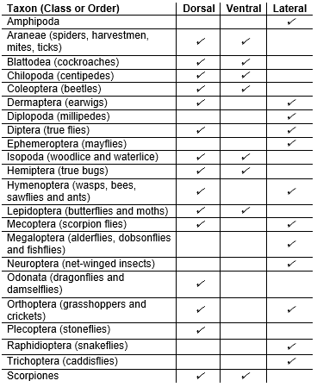
4. Additional comments: | The image should be taken in the highest quality resolution - macro lens recommended.  Photograph to include a unique identifier (e.g. QR code, NHMUK barcode) where possible; where no voucher specimen parts are retained (e.g. genitalia, wings or other) the photograph will serve as voucher and should include identifying features.  The photos should be of high enough resolution to be diagnostic, when possible.  Often, terrestrial species can be photographed live when anaesthetised (CO2 or ethyl acetate are both effective) for diagnostic photography. When specimens are anaesthetised, you are also able to observe and photograph parts of the anatomy at high magnification under a microscope. These features may be less clear once the specimen is frozen.
Dissection:
5.1. Specimen is larger than a lentil (ca. 5 mm) | Y
5.2. Part of specimen dissected for DNA barcoding | Leg(s), number depending on size of the specimen, number of legs present and volume of tissue.  The tissue for barcoding is removed, put in 100% ethanol. The rest of the frozen/live organism can then be dissected.
5.3. Dissection for whole genome | One dissected section per tube is required with a unique barcode/ relevant unique identifier (e.g. QR code, NHMUK number) associated with the tube number.  Please use the following recommendations for taxon-specific dissection:  Insecta: In separate tubes: head, thorax, abdomen if they take up 5mm chunks; depending on body part size can be fragmented further. For specimens under 5mm see section TSS3.  Amphipoda: Remove pleopods for DNA barcoding and whole genome. The rest of the whole body would act as a voucher. This is recommended for specimens over 10mm. For specimens under 10mm, please refer to section TSS3.  Araneae: In separate tubes: cephalothorax, abdomen, legs (if any left after taking samples for barcoding); depending on size to be further fragmented.  Pedipalps of male specimens and abdomen of female specimens should be preserved in ethanol and retained as vouchers.  Opiliones: In separate tubes: cephalothorax, abdomen, legs (if any left after taking samples for barcoding).  Scorpiones: In separate tubes: prosoma (cephalothorax), mesosoma, metasoma, pedipalps (pincers); can be fragmented further if needed.  Diplopoda: Mid section of the body (trunk) should be dissected into approximately 5 mm chunks.  Head and seven anterior body segments, also last leg-bearing segment and terminal segments including telson should be preserved in ethanol and retained as vouchers.  Chilopoda: Mid body should be dissected into 5mm chunks.  Head and two anterior leg-bearing segments, also two to three last leg-bearing segments including last pair of legs should be preserved in ethanol and retained as vouchers.  Isopoda: Body dissected into 5 mm chunks (anterior & posterior).  Pleon and hind legs should be preserved in ethanol and retained as vouchers.  Immature life stages of hemimetabolous taxa: To be dissected as their adult stage.  Pictorial dissection guides TSS1 available for more specific dissection information.
5.4. Estimated number of sections (per specimen) dissected for genome sequencing (into separate FluidX tubes): | Up to 10; could be more depending on arthropod size. Should be dissected into 5 mm chunks.
5.4. Additional comments: | Parts taken for vouchers should be stored in 70-90% ethanol, except wings which should be retained dry in an envelope. See section 8 and 9 for more details on taxon specific vouchering methods.  Ensure all tube barcodes are linked with the original relevant unique identifier (e.g. QR code number).
Storage of frozen tissue:
6. All prepared tubes with frozen dissected tissue sent to? | If passes the DNA barcoding stage; the Wellcome Sanger Institute.  Please refer to DNA barcoding SOP v2.1.
7. Leftover tissue from large specimens sent to NHM for vouchering and long term storage? | Y
6.& 7. Additional comments: | The samples for genome sequencing will be sent to Sanger.  Any sample extracts will be sent by Sanger to NHM for long-term storage.
Storage of voucher:
8. Sent to/kept at NHM as voucher? | Y
9. Voucher preparation technique, as per NHM guidelines. | Vouchered tissue preserved in 70-90% ethanol.  Pictorial dissection guides TSS1 available for more taxon specific vouchering information.  Voucher methods  For certain families genitalia may need to be dissected out (Diplopoda, Chilopoda, Araneae, Calyptrate flies) or dissected/slide mounted (various insect groups) to allow for positive identification.  The dissected genitalia or slides should be retained as a voucher, in a vial with 70-90% ethanol. Genitalia are removed by cutting the end of the abdomen off the freezing specimen (ideally before it is completely frozen and then liable to ping off).  Wings in cellophane envelope: Lepidoptera, Mecoptera, Odonata, Raphidioptera  For some species of specialist interest, eg. in Lepidoptera, the abdomen can also be stored as a voucher for diagnostic purposes, alongside the winds.
SOP checked by expert? | Y

TSS1: Pictorial dissection guides

Figure 1: Coleoptera
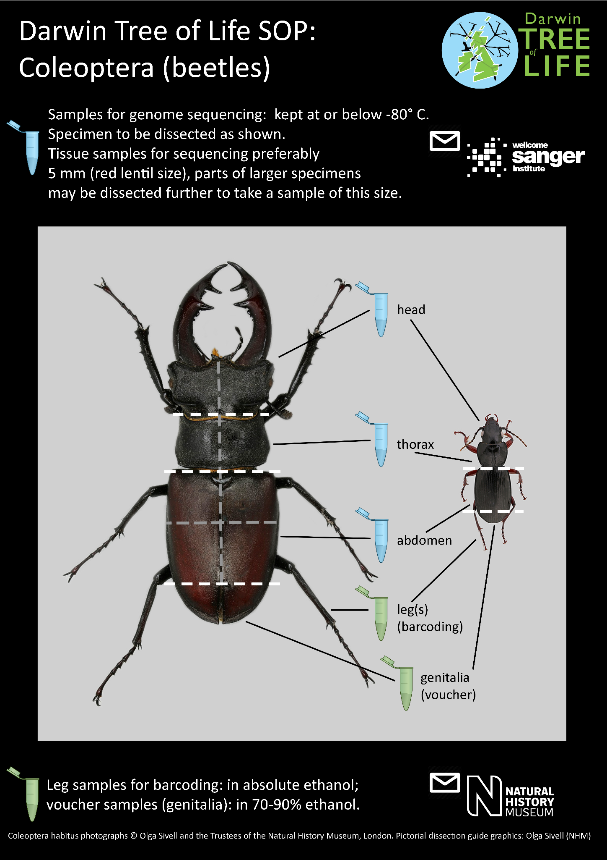

Figure 2: Blattodea
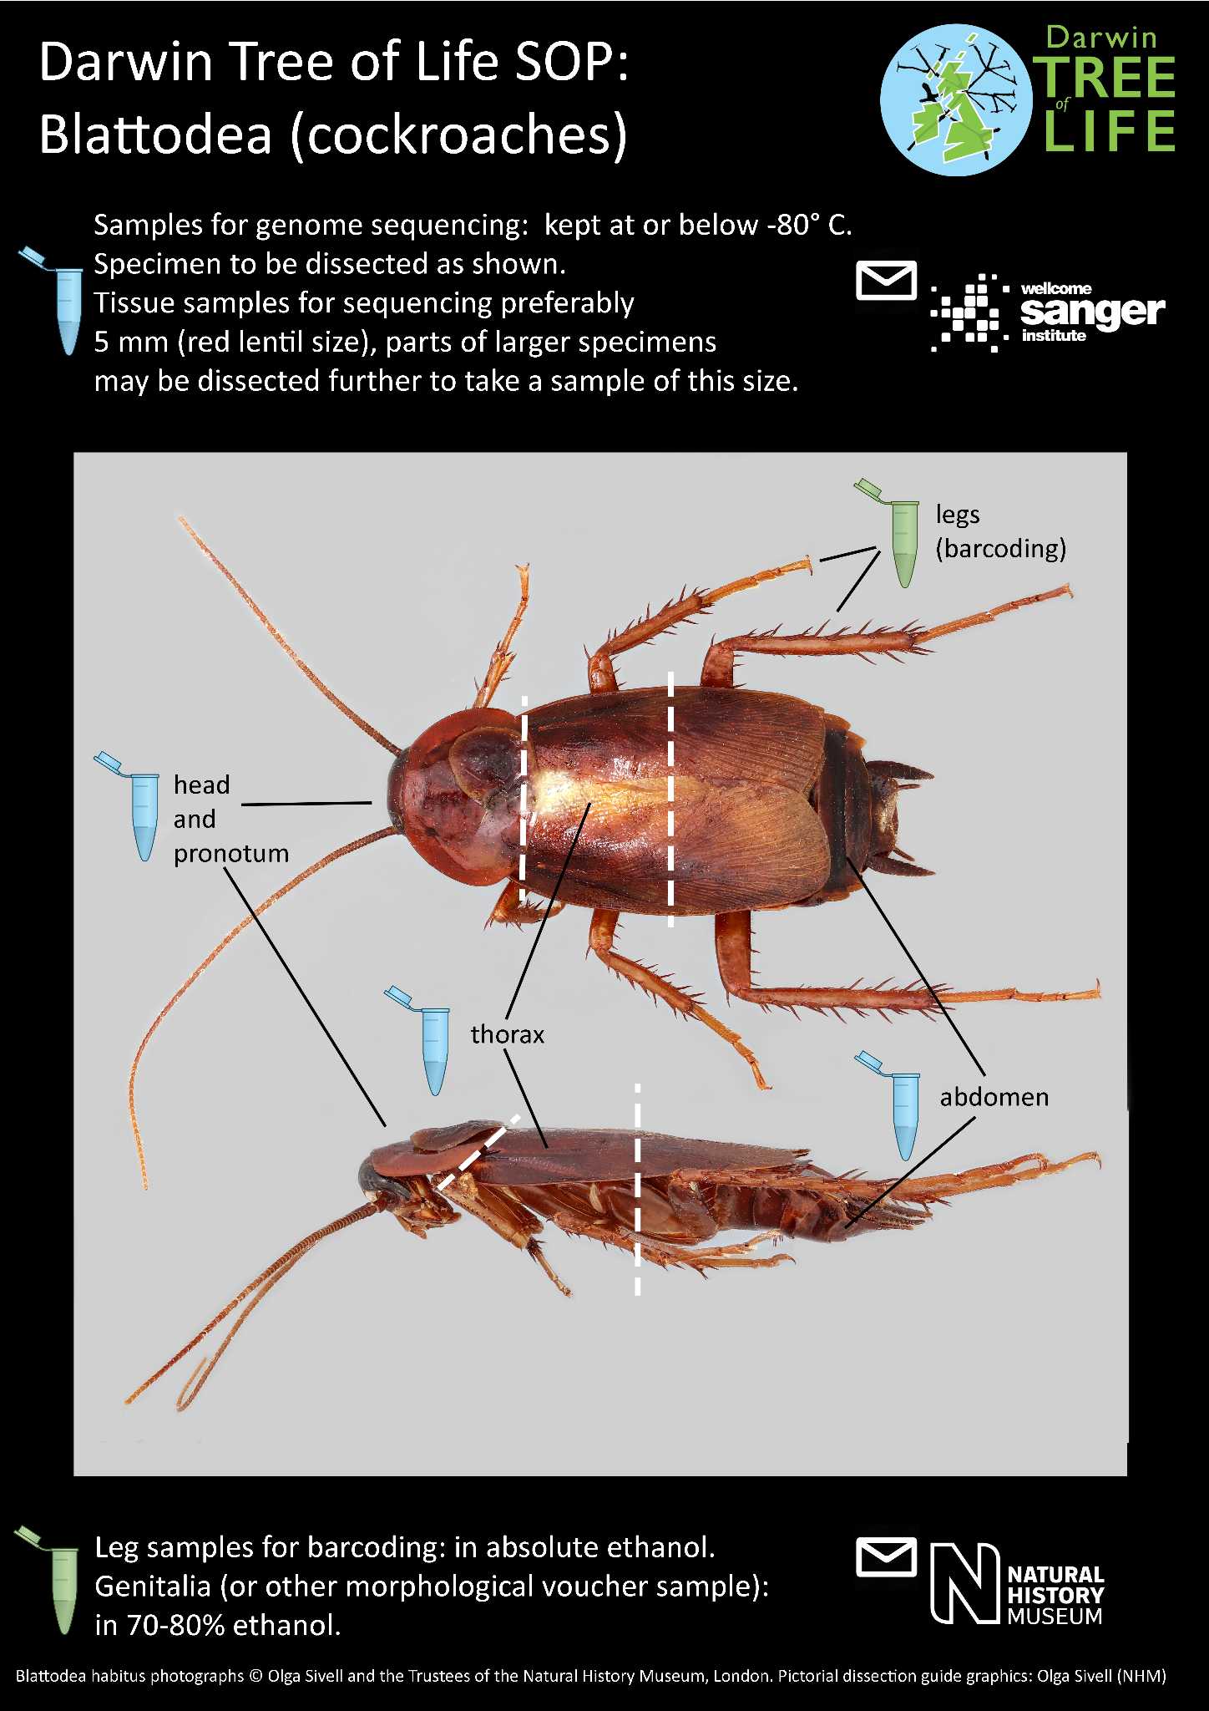

Figure 3: Diptera
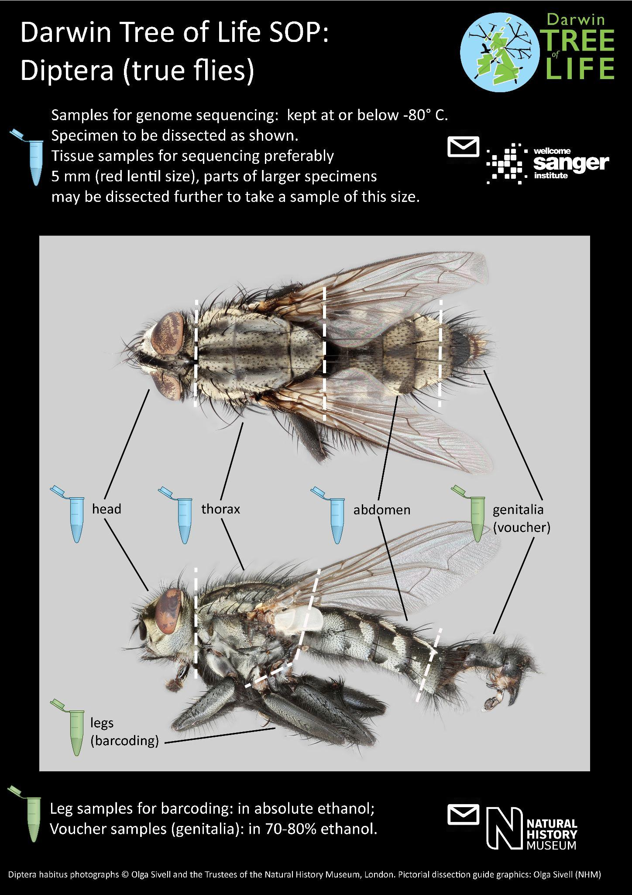

Figure 4: Hemiptera
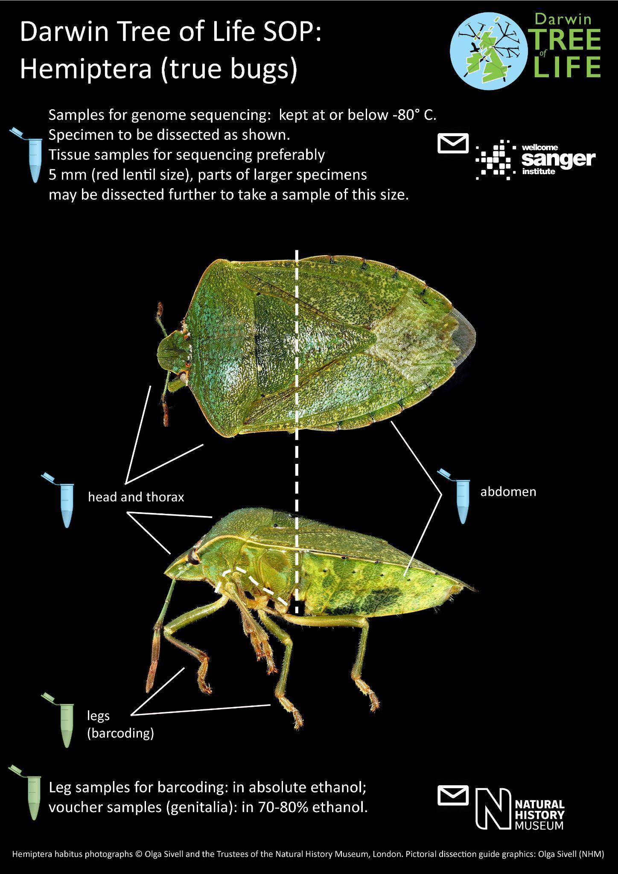

Figure 5: Hymenoptera
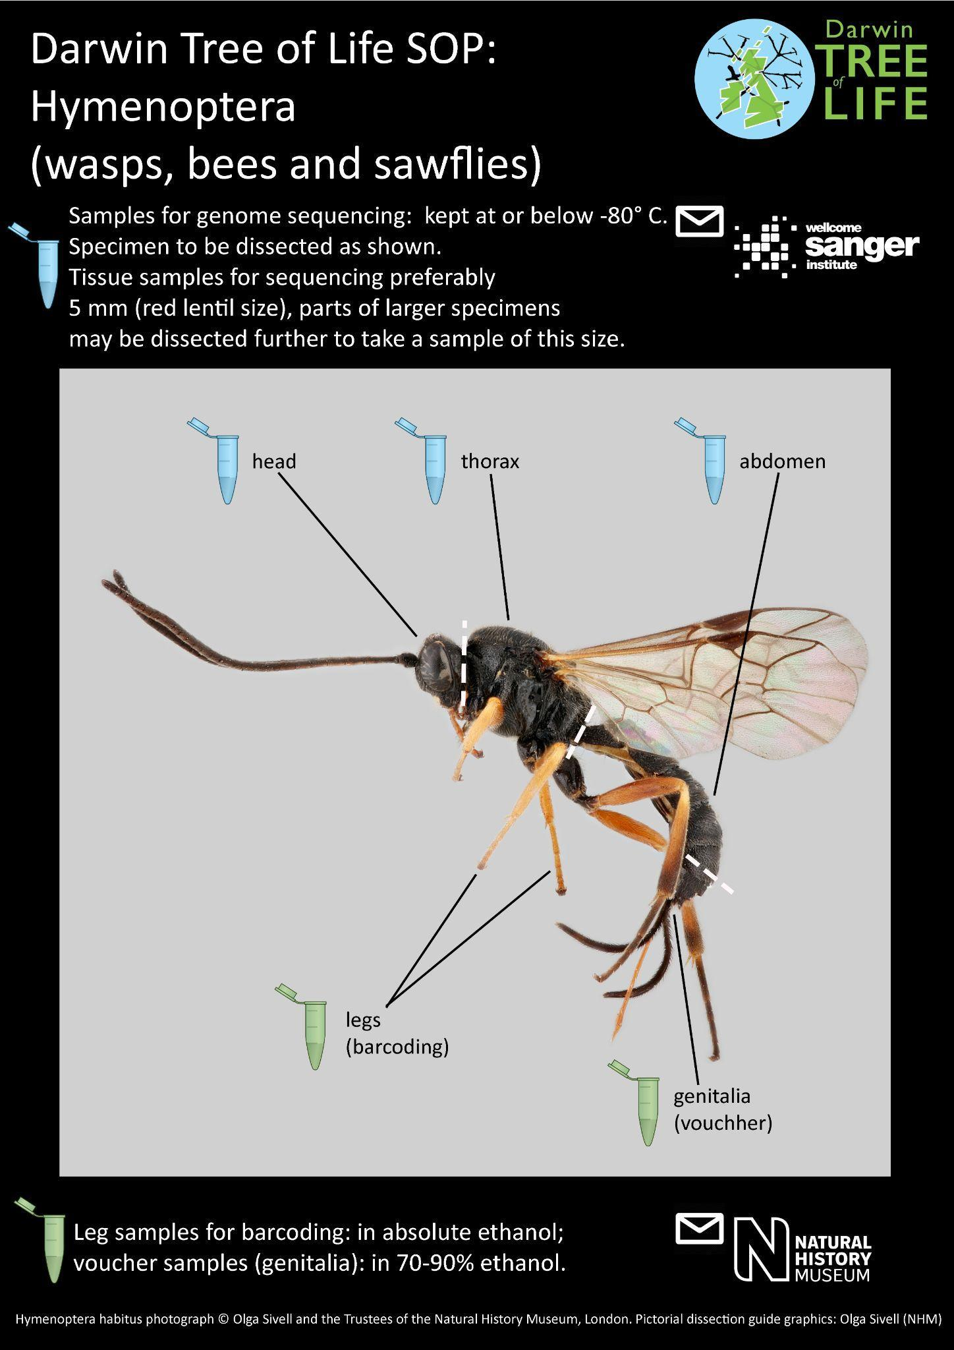

Figure 6: Lepidoptera
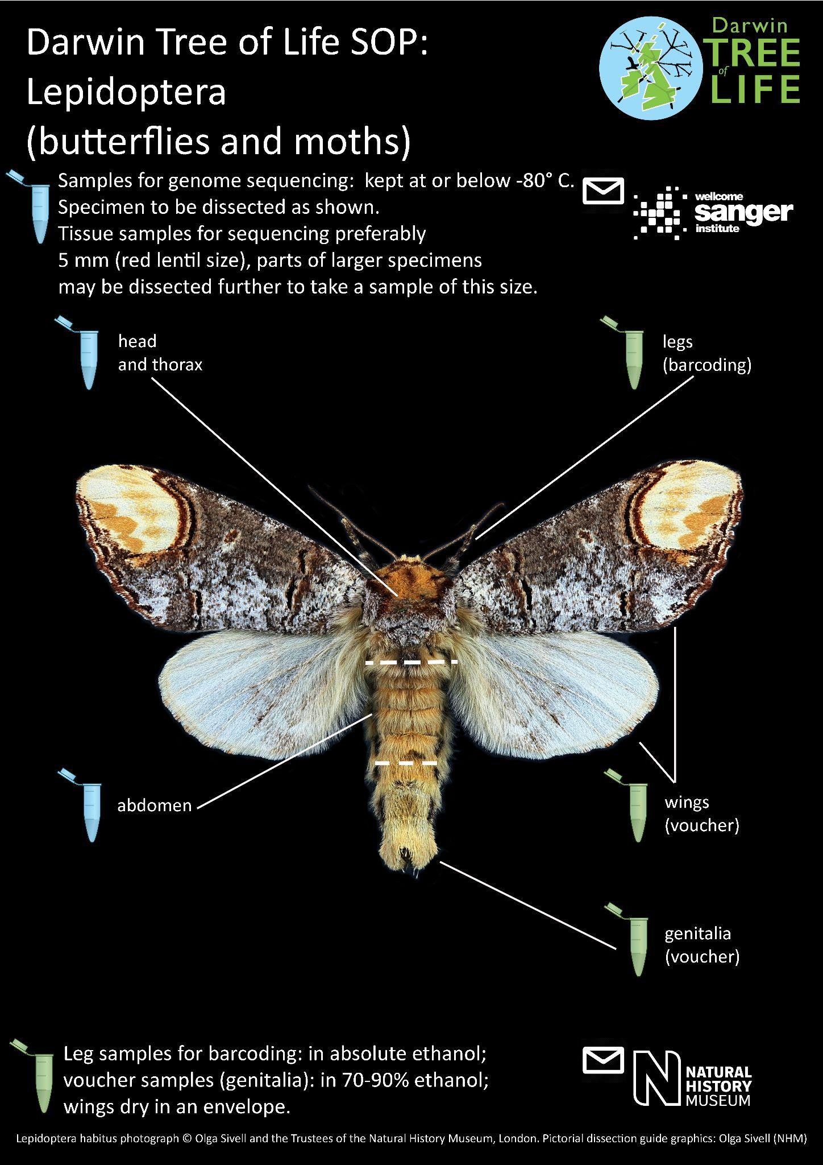

Figure 7: Araneae
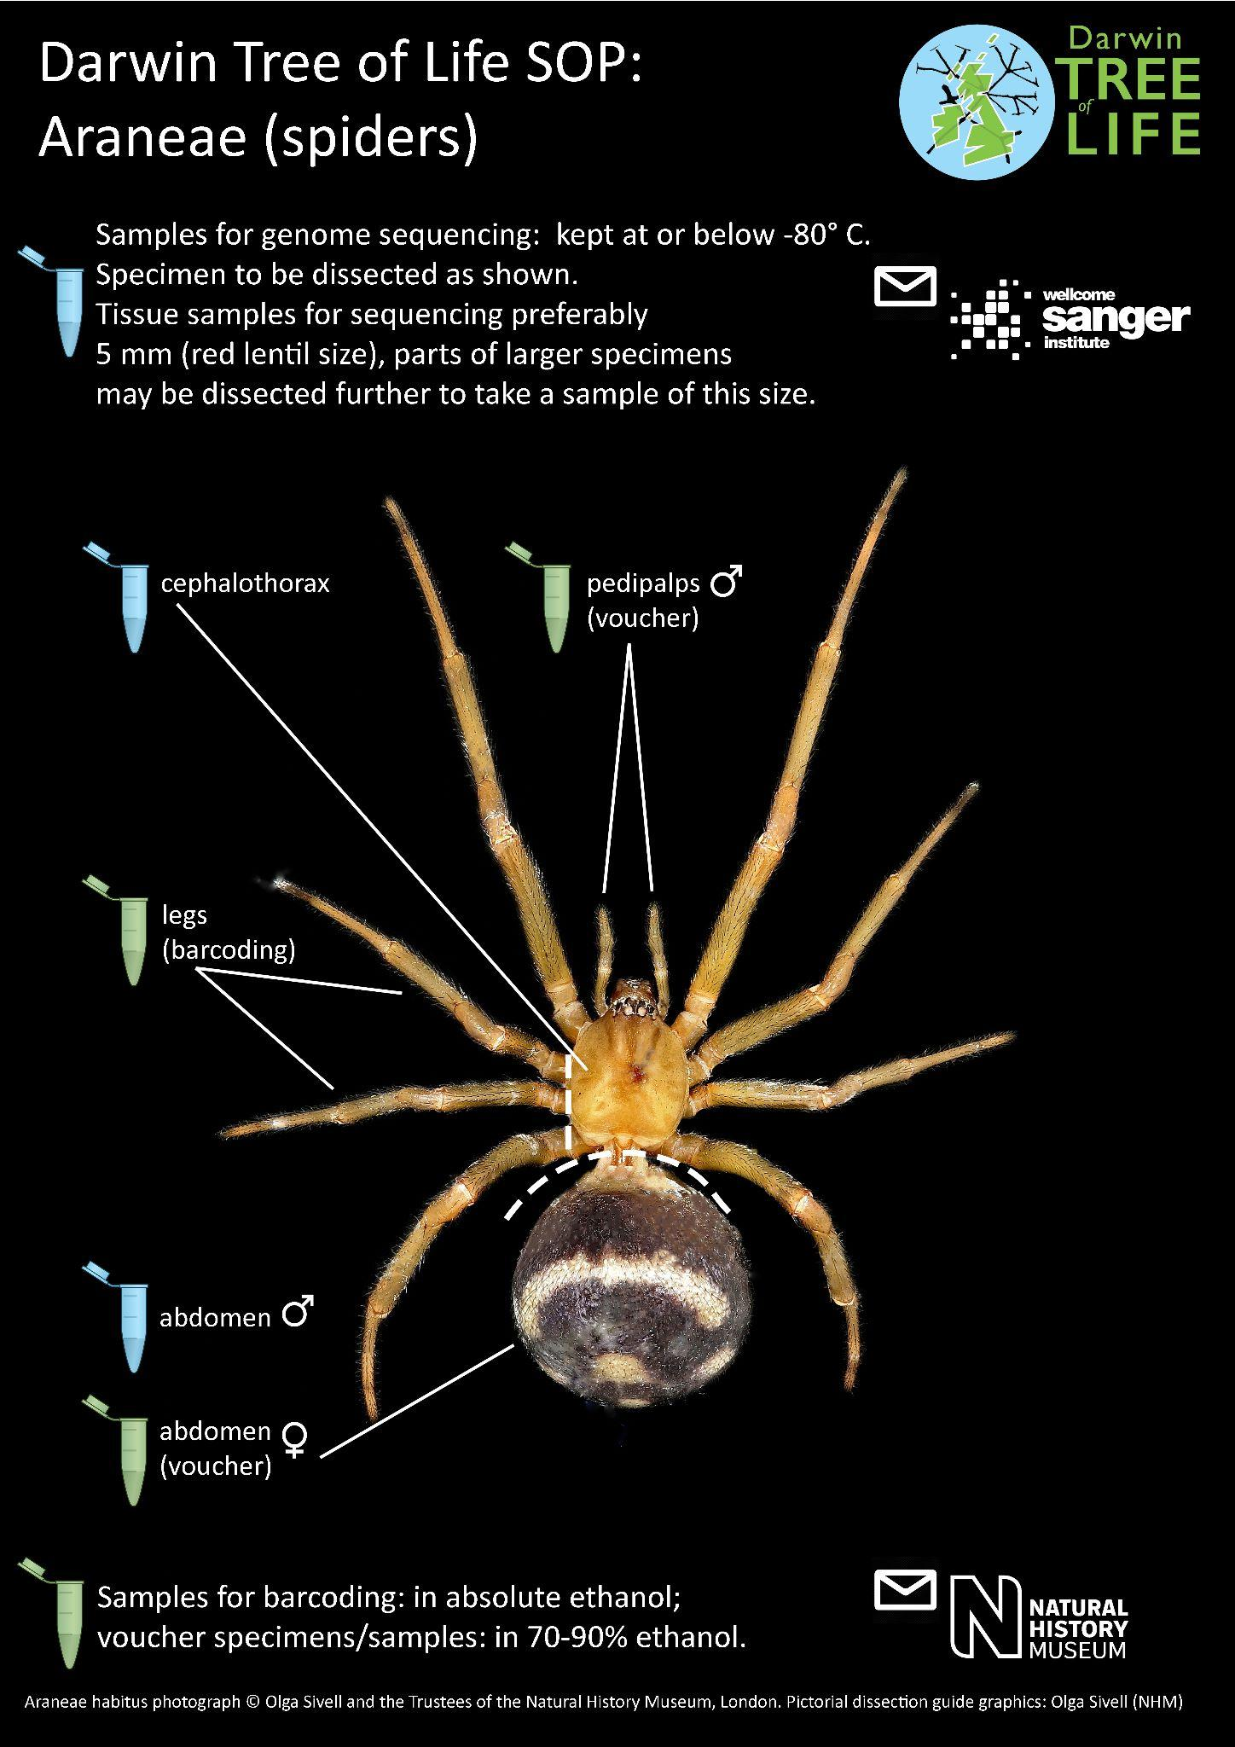

Figure 8: Opiliones
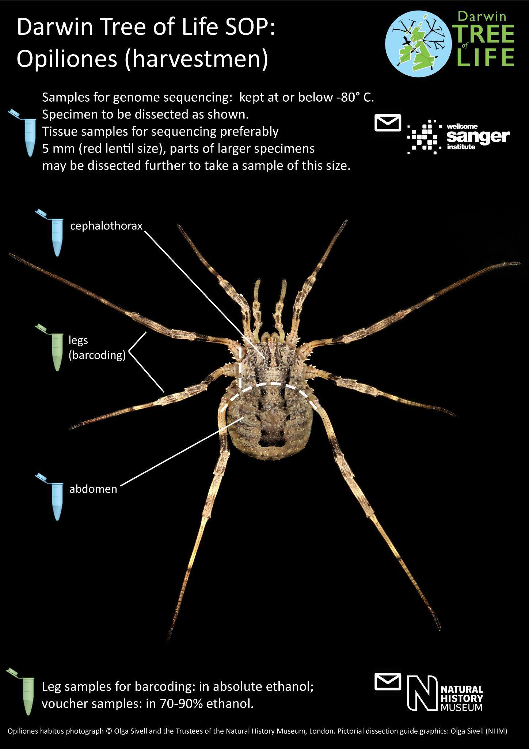

Figure 9: Trichoptera
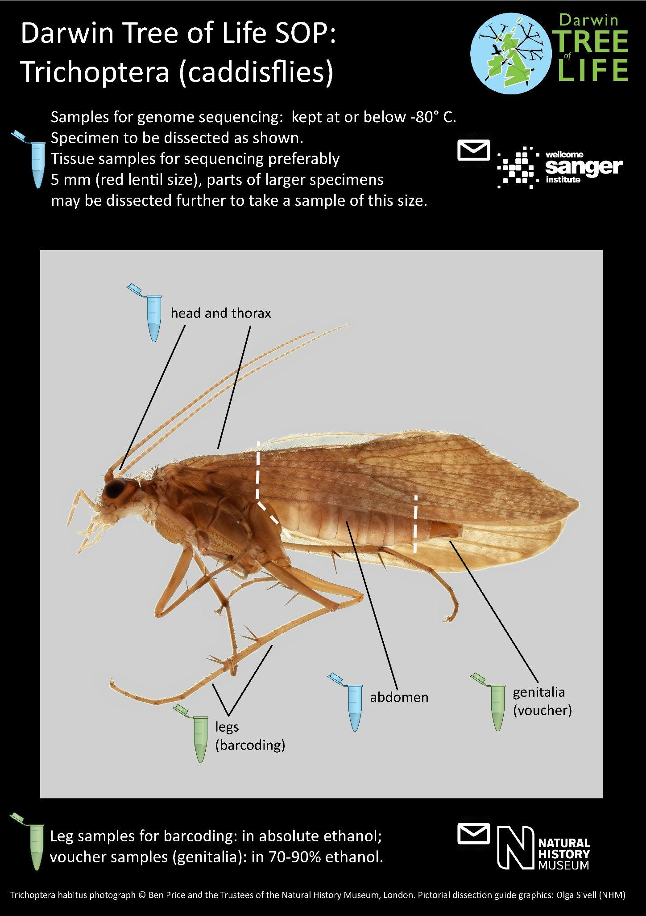

Figure 10: Mecoptera
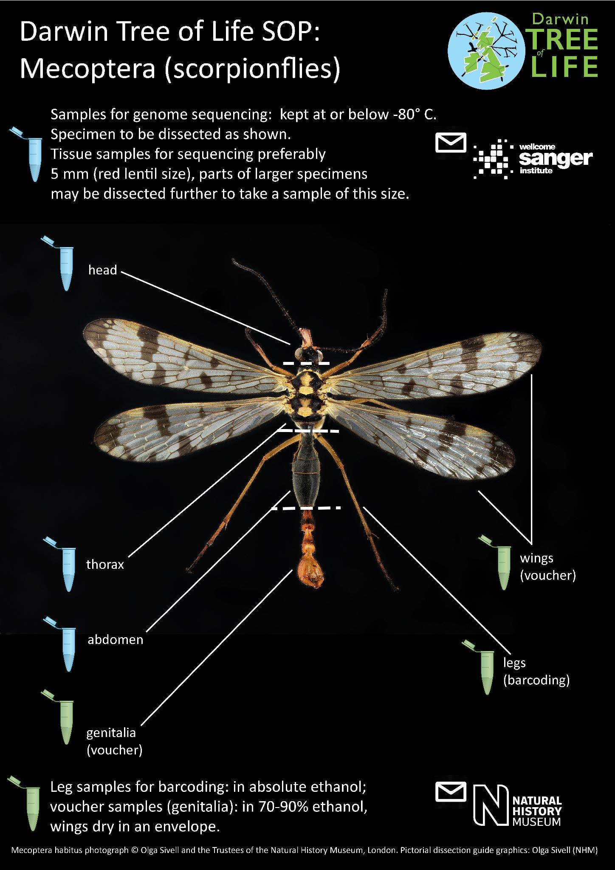

Figure 11: Plecoptera
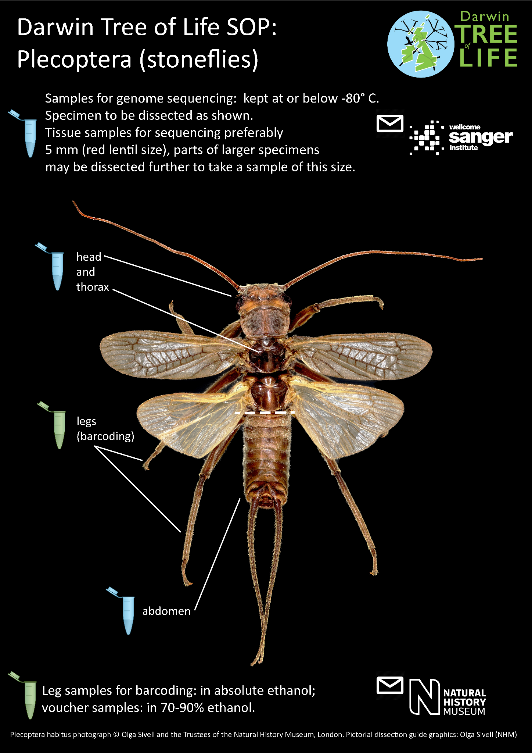

Figure 12: Odonata
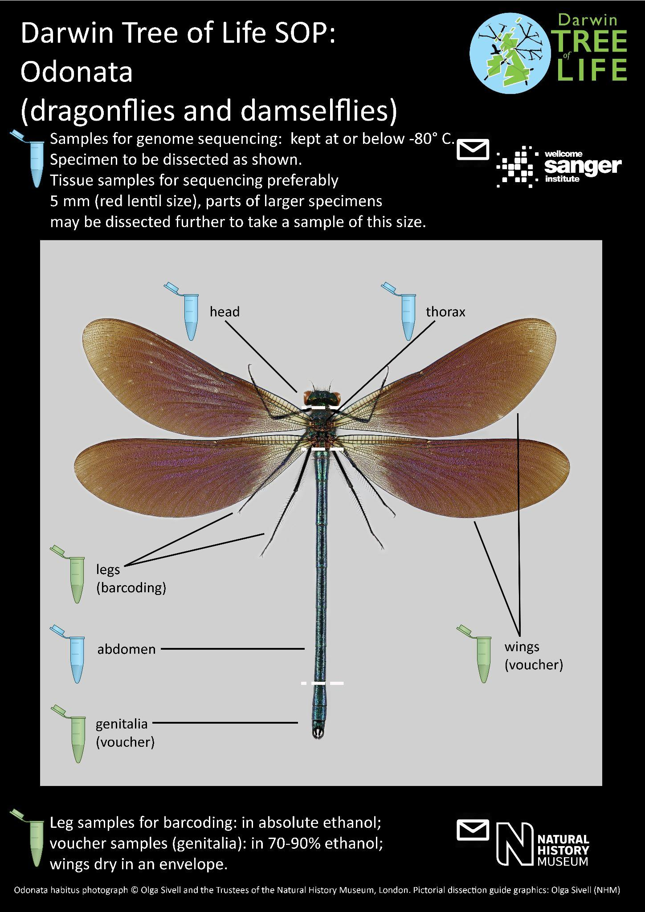

Figure 13: Raphidioptera
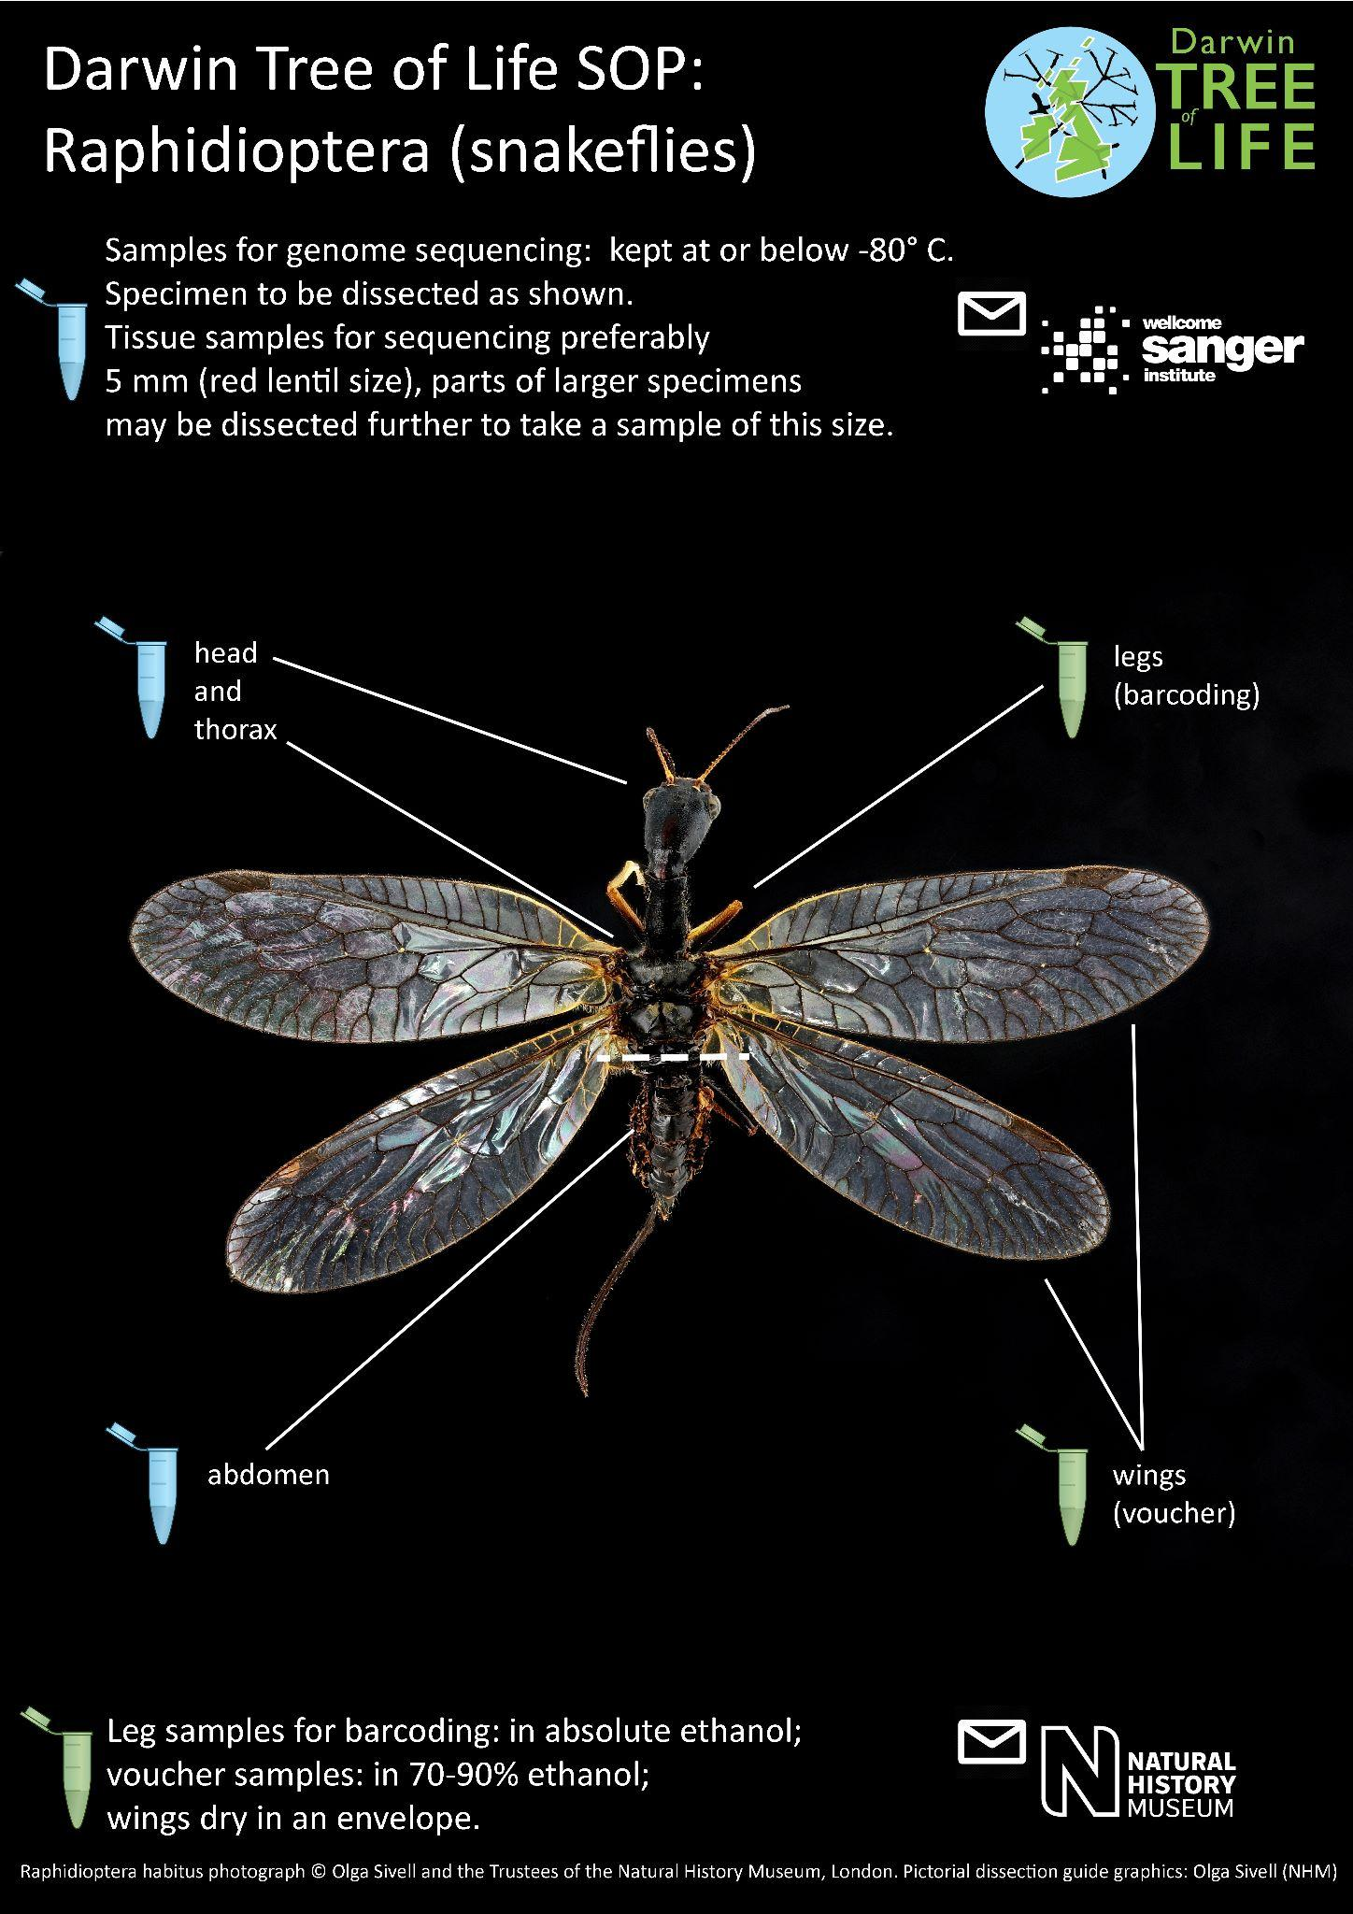

Figure 14: Orthoptera
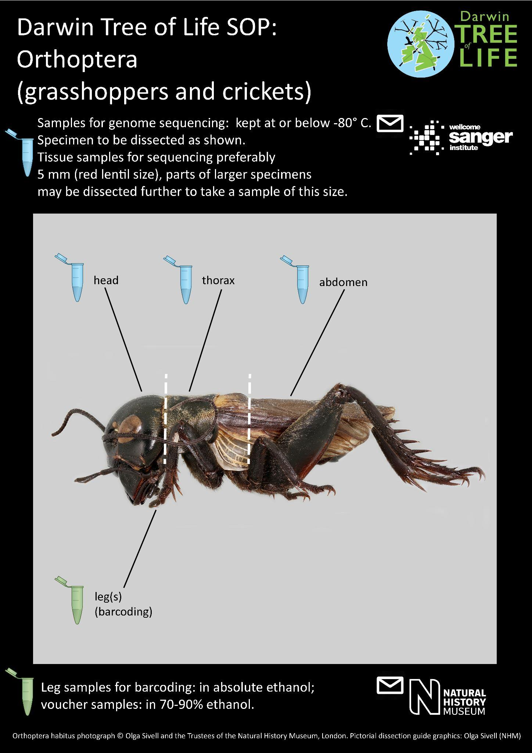

Figure 15: Ephemeroptera
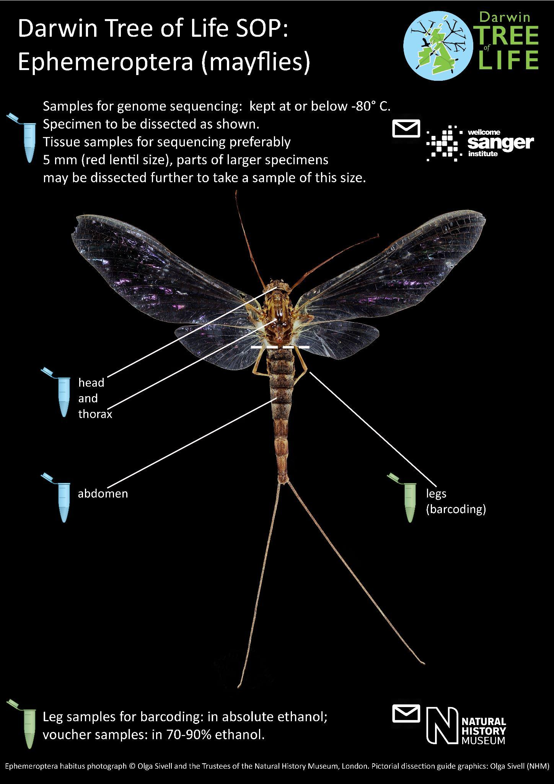

Figure 16: Dermaptera
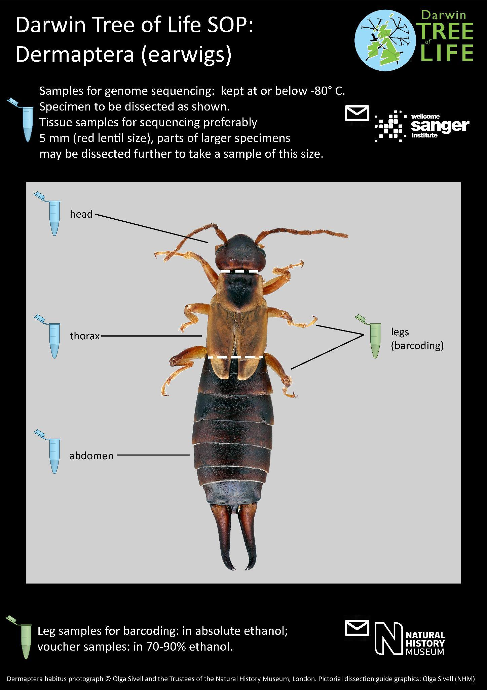

Figure 17: Neuroptera
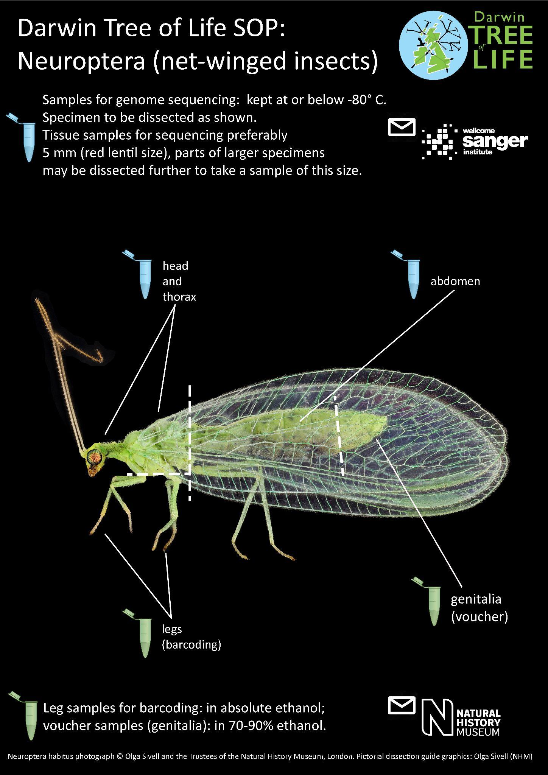

Figure 18: Chilopoda
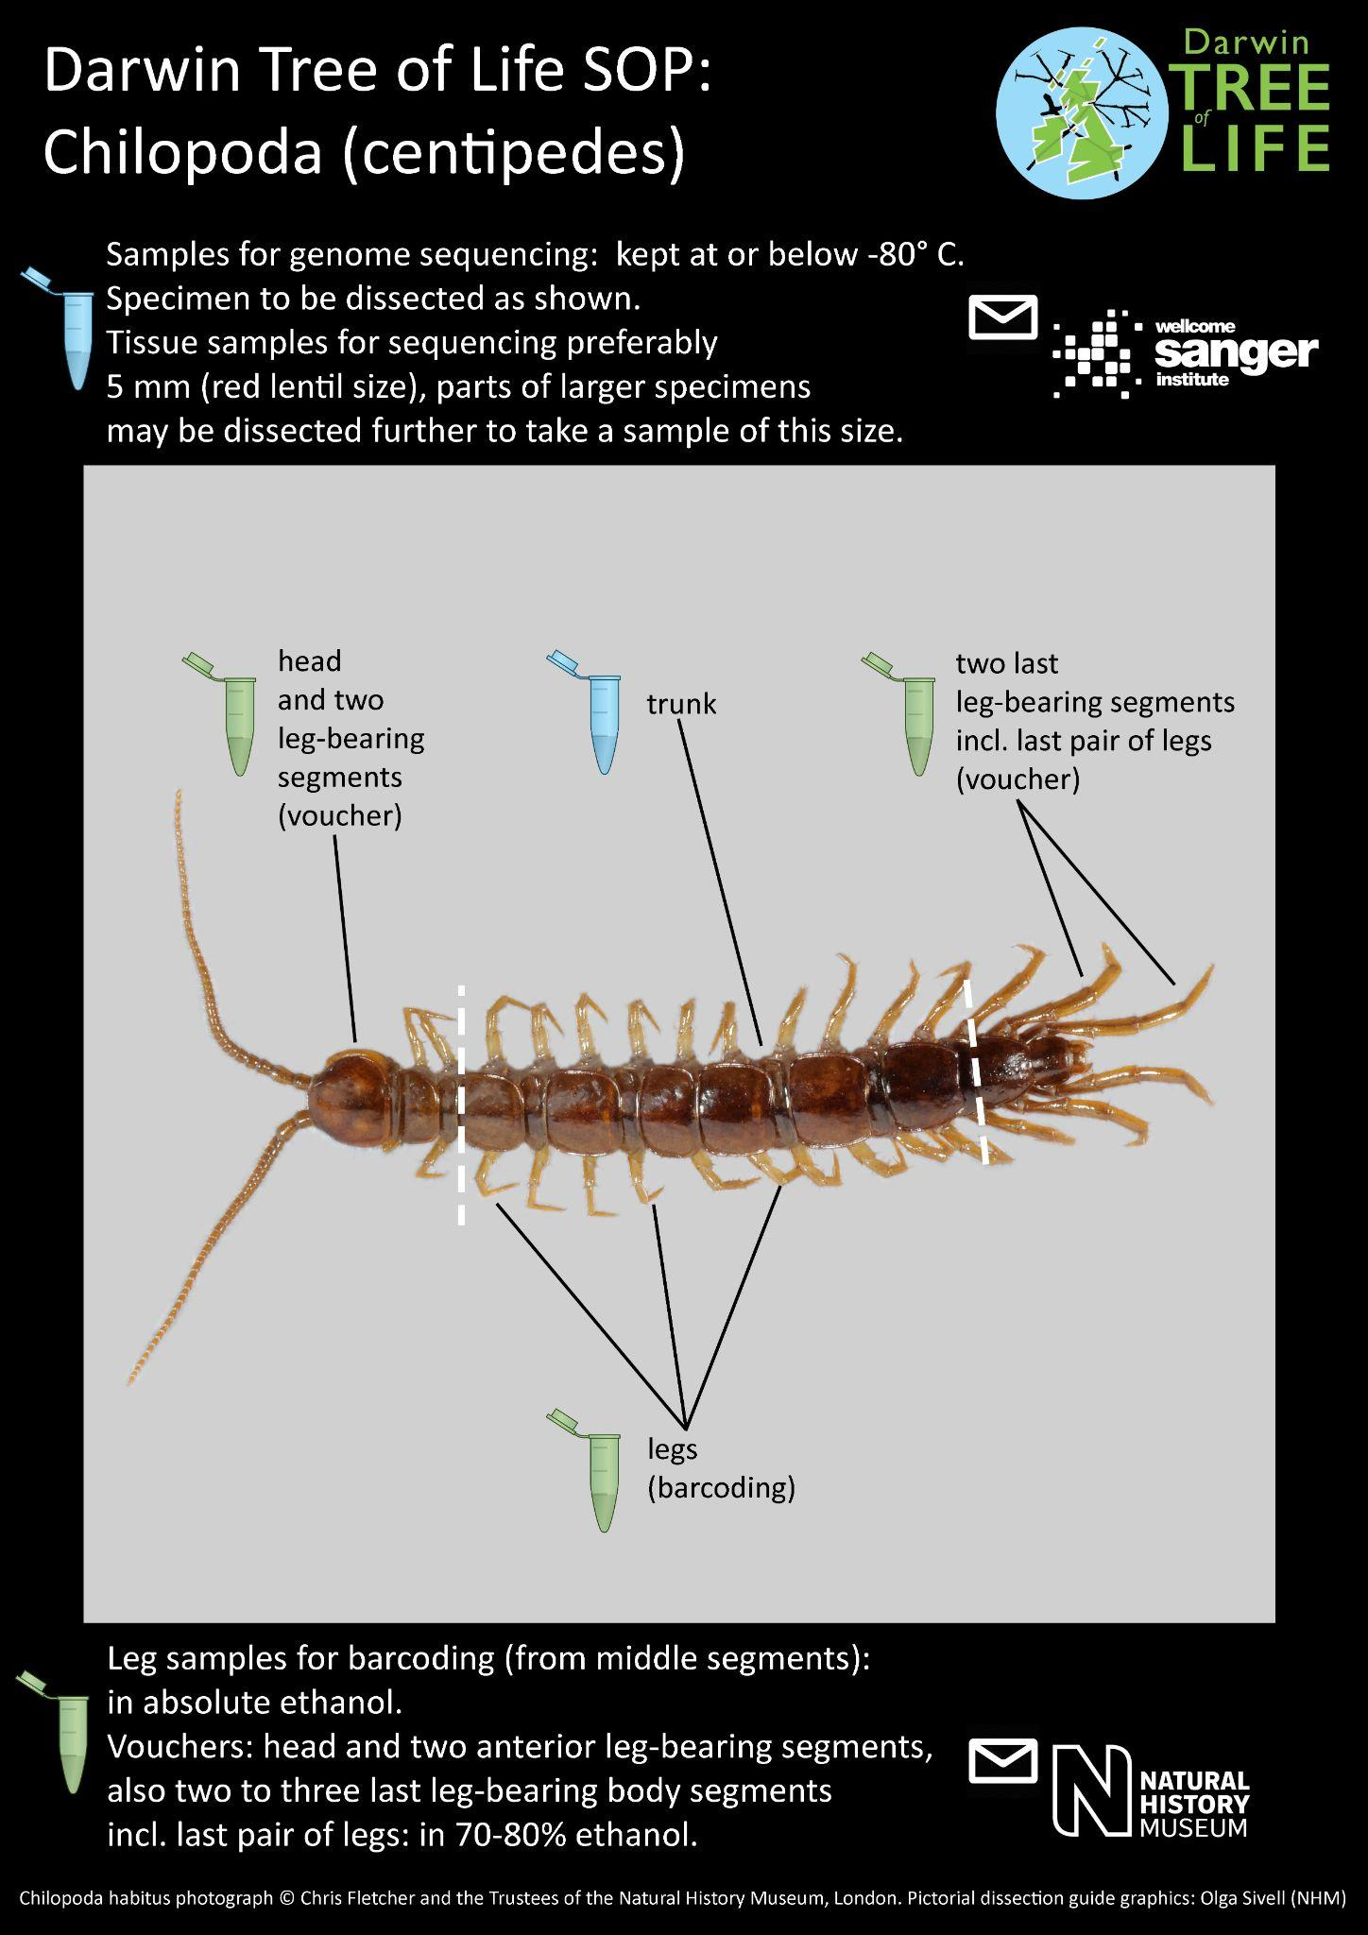

Figure 19: Diplopoda
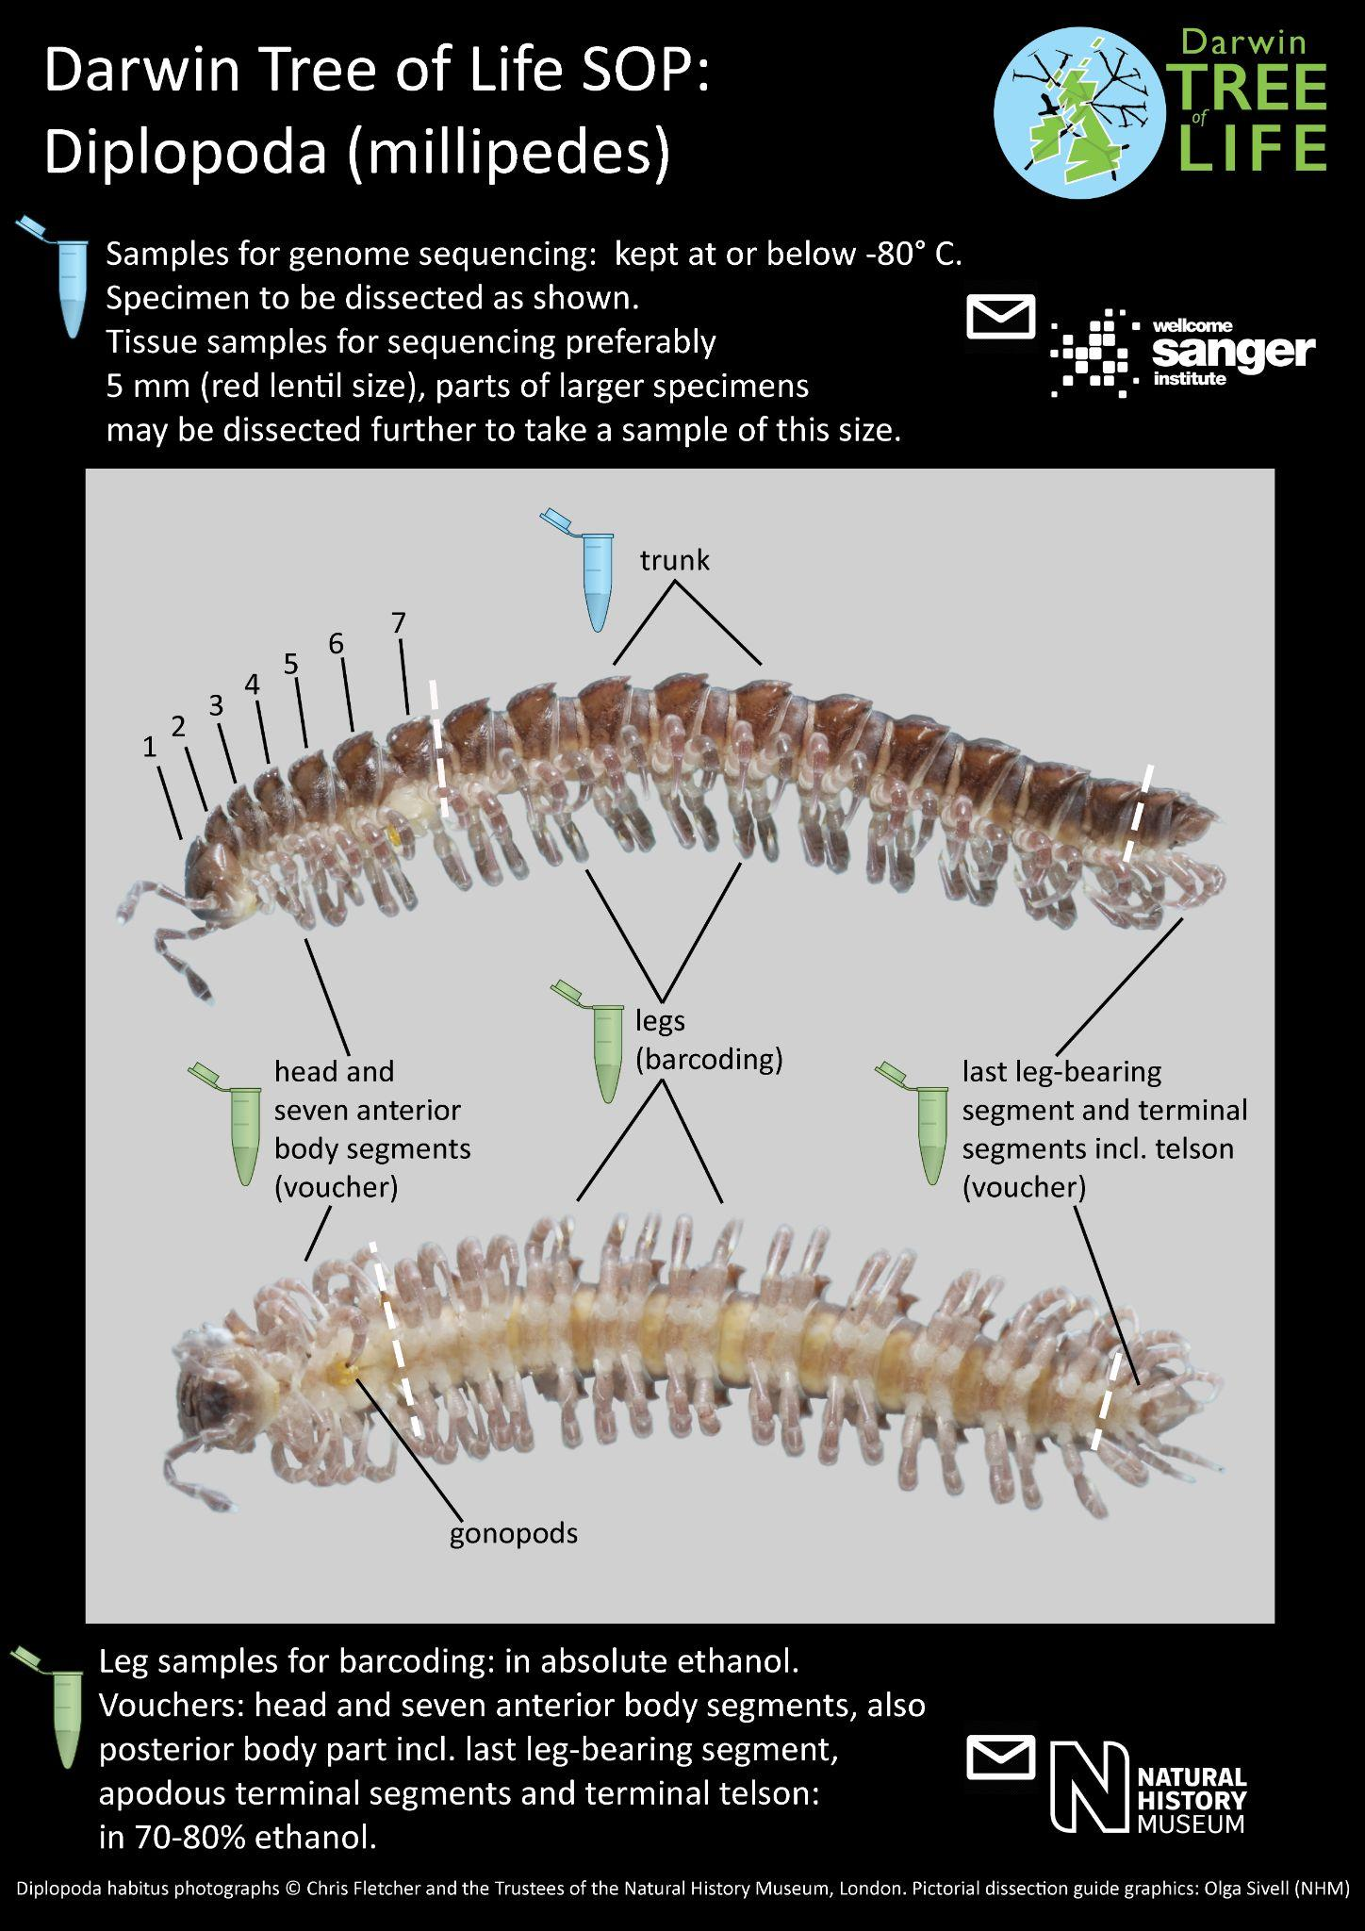

Figure 20: Scorpiones
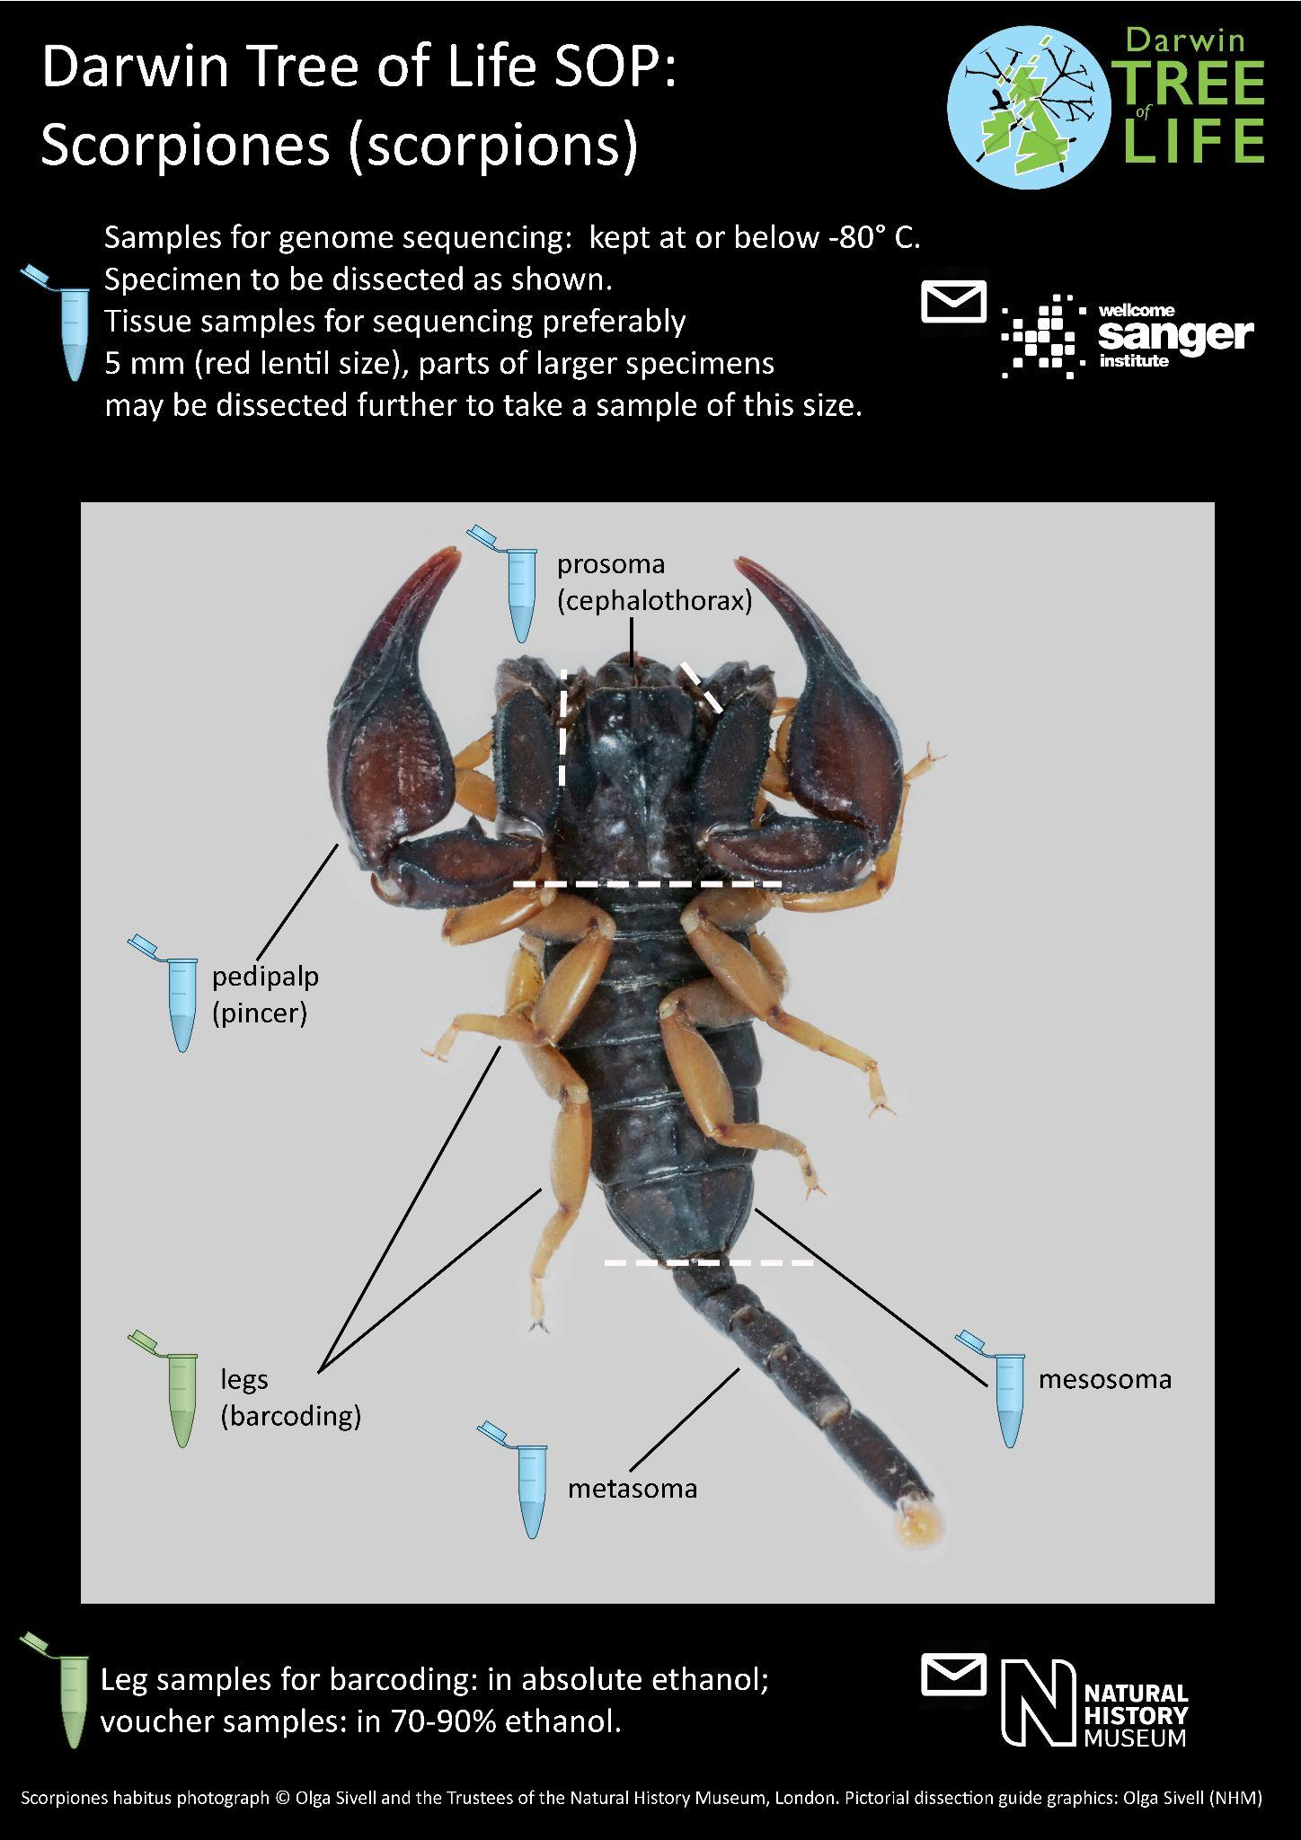

Figure 21: Isopoda
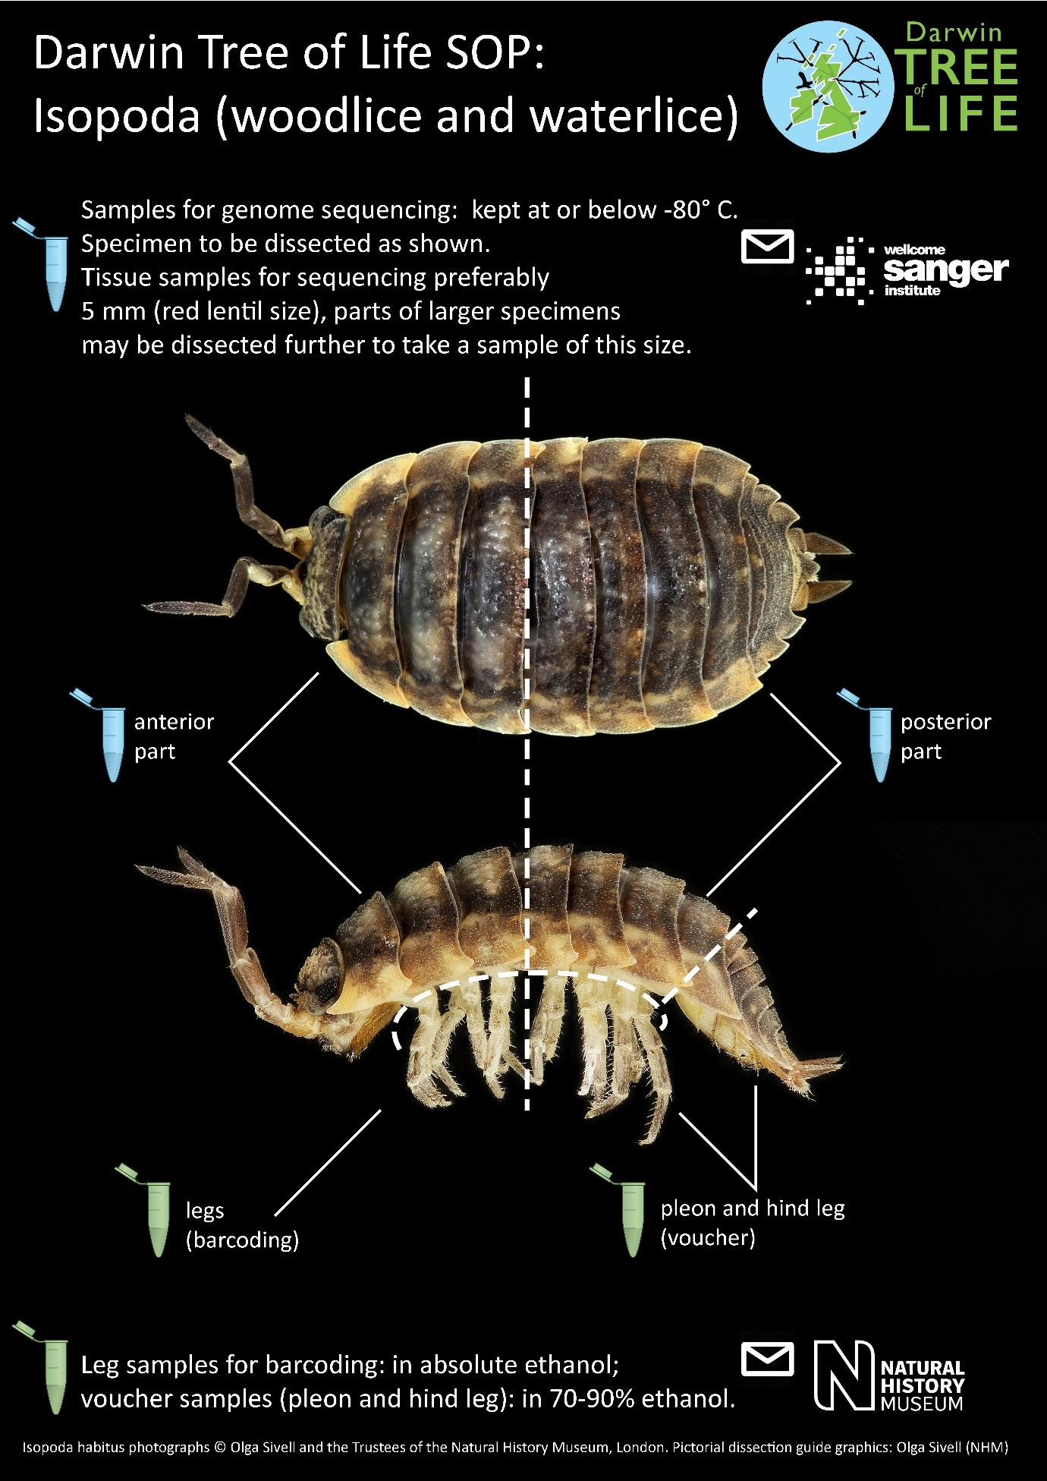

Figure 22: Amphipoda
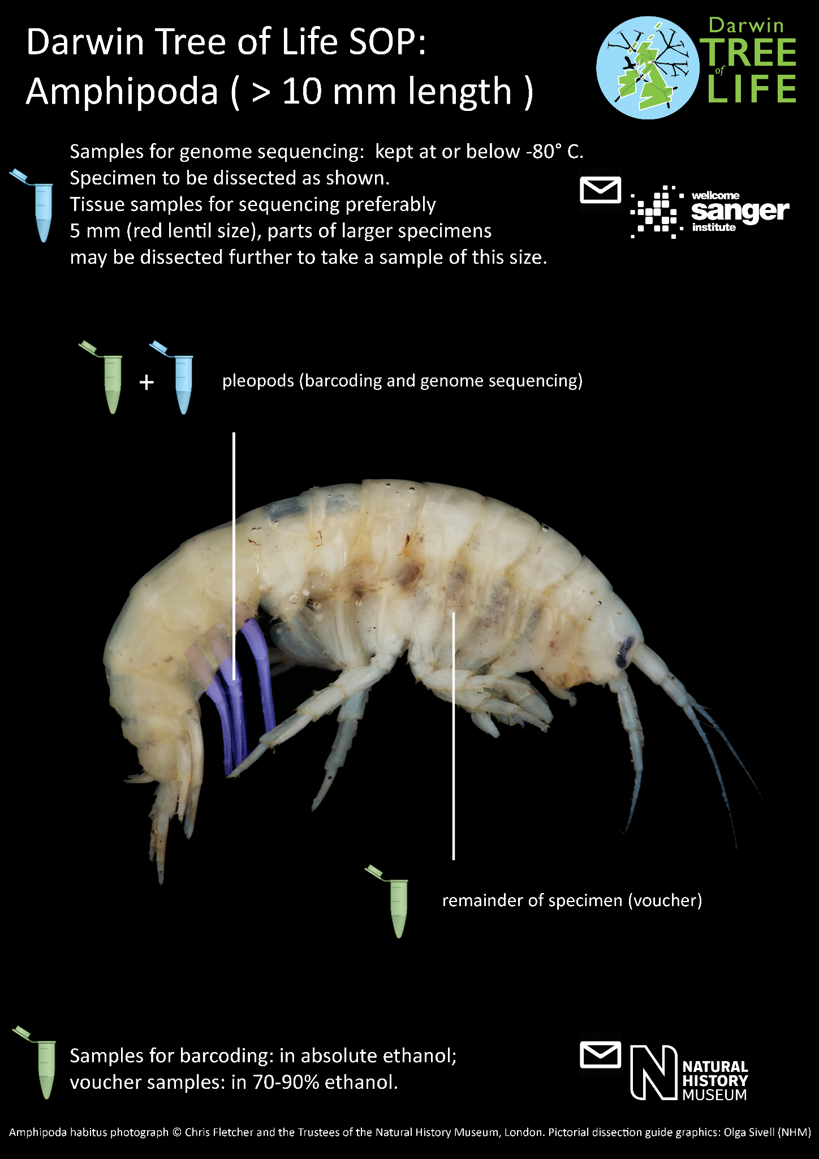

Figure 23: Hemimetabolous nymphs – example taxon, Ephemeroptera
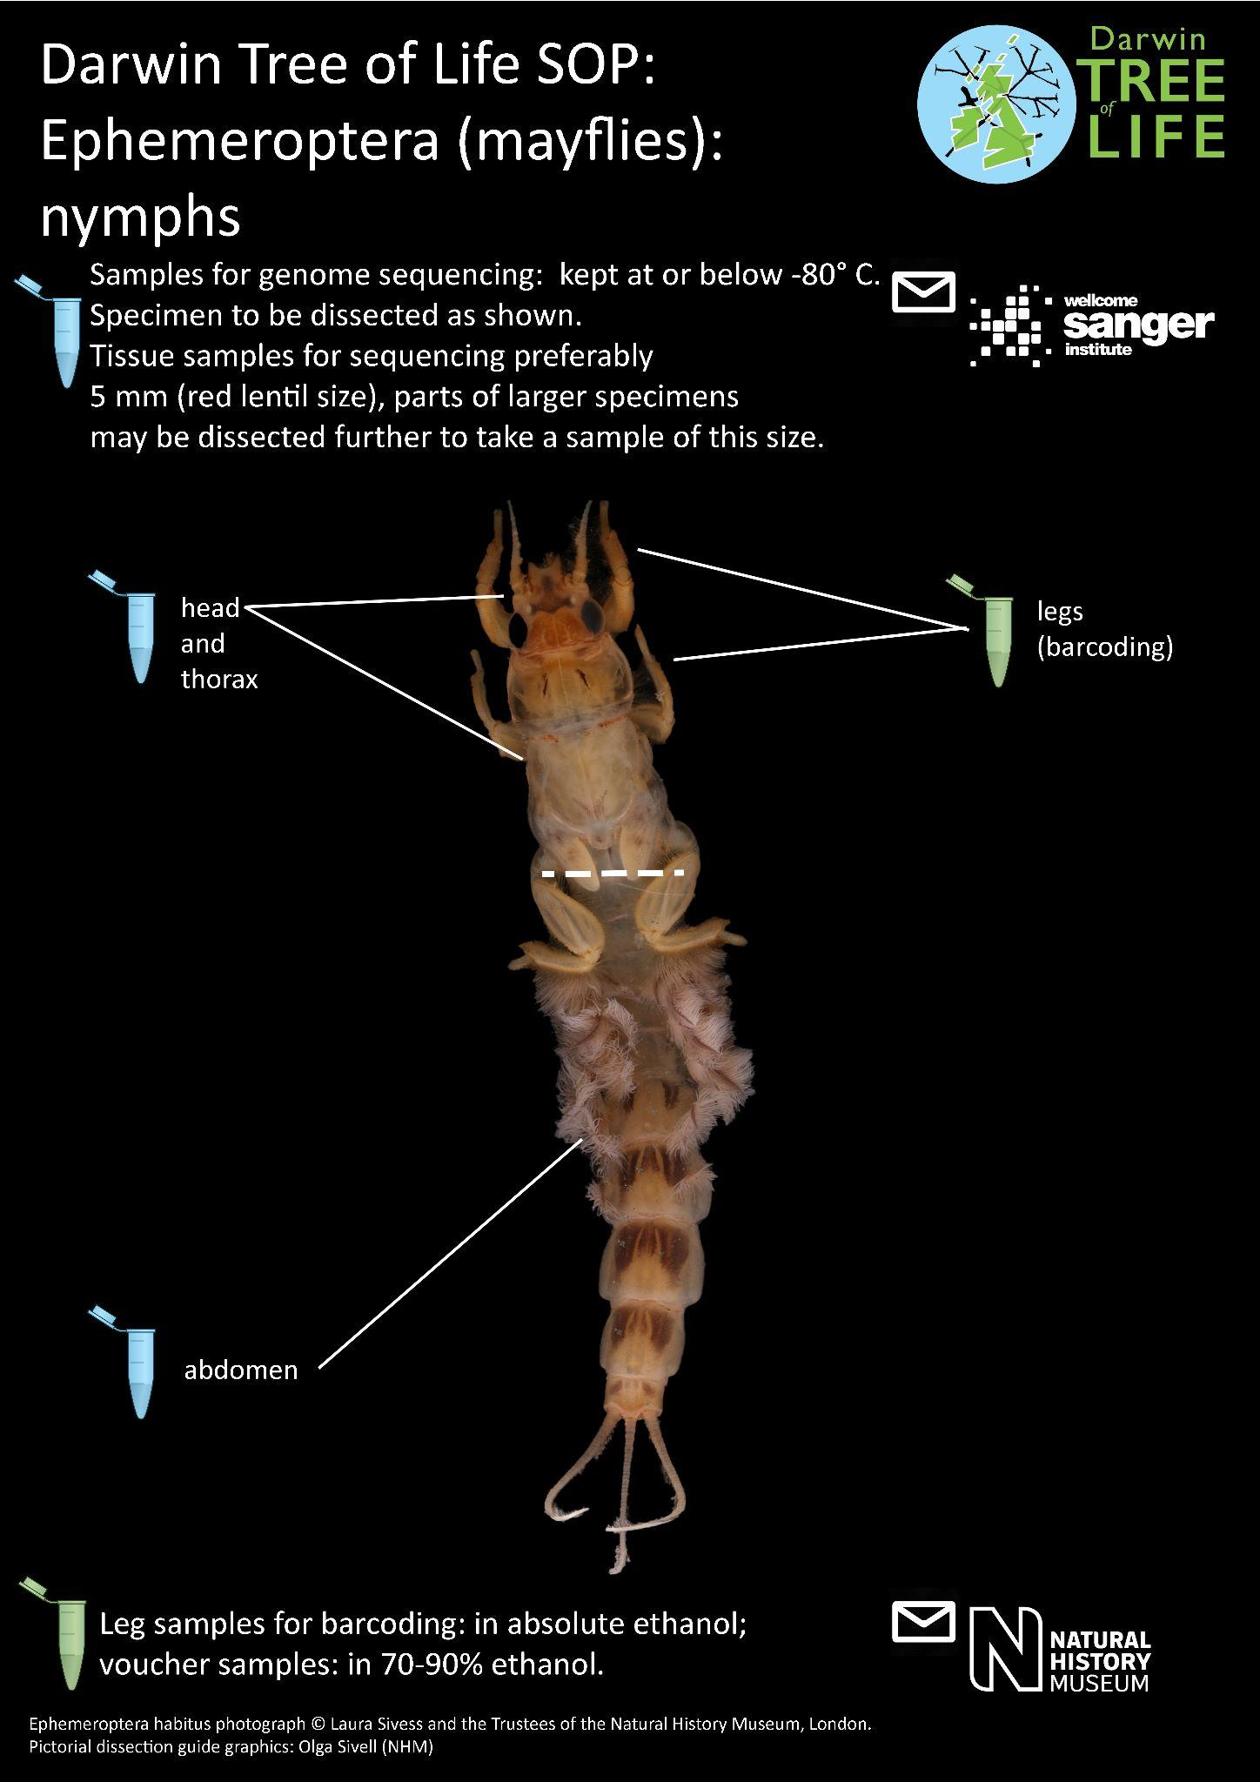

TSS2: Taxon group: Larval stage insects

Definition: Holometabolous insect larvae and pupae

Including: Coleoptera, Diptera, symphytan Hymenoptera, Lepidoptera, Mecoptera, Megaloptera, Neuroptera, Raphidioptera, Trichoptera.

Excluding: Specimens smaller than 5mm.
Detail | Select
Field sampling:
1. Environment to be sampled: | Terrestrial and freshwater.
2. Trap/method of sampling: | Specimens will be live caught, single target or bulk capture (up to five specimens of the same species collected if possible).  If aquatic: collected with a kicknet; live specimens sorted in a tray of water.
1.& 2. Additional comments: | Each specimen, regardless of species, must have its own unique ID (eg. QR code number) which will be attached to any genome or barcoding results.

For genome sequencing
Tissue preparation:
3. Can specimens be sampled and frozen while still alive? | Y
3. Additional comments: | Must be frozen at -80˚C or lower.  Specimens to be identified (where possible up to genus as a minimum) and photographed prior to tissue preparation for genome sequencing. If the larvae originate from a gall it may also be retained or photographed to aid the identification process. Larvae reared from an egg cluster may also be sampled and used for ID verification of specimens from the same batch used for genome sequencing.  Freshwater specimens should be imaged live, in water.  Case-bearing larvae to be removed from the case prior to freezing and samples being taken.  Pupa to be removed from the pupal case/cocoon prior to freezing and samples being taken.
Photography:
4. Photography appropriate for taxon: | Dorsal and lateral, additional views as required.  Plecoptera: ventral view.  Hymenoptera: Symphyta: both lateral views.
4. Additional comments: | The image should be taken in the highest quality resolution - macro lens recommended.
Dissection: | Ensure all tube barcodes are linked with the original specimen
5.1. Specimen is larger than a lentil (ca. 5 mm) | Y
5.2. Part of specimen dissected for DNA barcoding: | Leg(s), if present. Number of legs removed will depend on the size of the specimen, number of legs and volume of tissue.  If no legs; fragment of mid-section.  The tissue for barcoding is removed, put in 100% ethanol. The rest of the frozen/live organism can then be dissected.
5.3. Dissection for whole genome | Frozen specimen to be dissected into separate tubes: head, mid section, abdomen if they take up 5mm chunks. Depending on size to be fragmented further. For specimens under 5mm see section TSS3.  For more detailed dissection guides per certain taxa, see section TTS2: Pictorial dissection guides.
5.4. Estimated number of sections (per specimen) dissected for genome sequencing (into separate FluidX tubes): | Up to 5.
5. Additional comments: | Ensure all tube barcodes are linked with the original relevant unique identifier (e.g. QR code number).
Storage of frozen tissue:
6. All prepared tubes with frozen dissected tissue sent to? | If passes the DNA barcoding stage; the Wellcome Sanger Institute.  Please refer to DNA barcoding SOP v2.1.
7. Leftover tissue from large specimens sent to NHM for vouchering and long term storage? | Y
6.& 7. Additional comments: | The samples for genome sequencing will be sent to Sanger.  Any sample extracts will be sent by Sanger to NHM for long-term storage.
Storage of voucher:
8. Sent to/Kept at NHM as voucher? | Y
9. Rest of specimen (voucher) curated in | Spirit (vial with 70-90% ethanol)
10. Voucher preparation technique | All larvae and voucher samples to be stored in 70-90% ethanol.  Head capsules or whole larvae may be slide-mounted later for ID verification. The recommended vouchers to be retained:  Coleoptera - head and thorax, also tip of abdomen with urogomphi if present; for legless larvae: head capsule.  Diptera - the head capsule and tail end  Hymenoptera - head capsule  Trichoptera - post removal from pupae, head capsule and tail end.
SOP checked by expert? | Y

TSS2: Pictorial dissection guides

Figure 24: Lepidoptera larvae

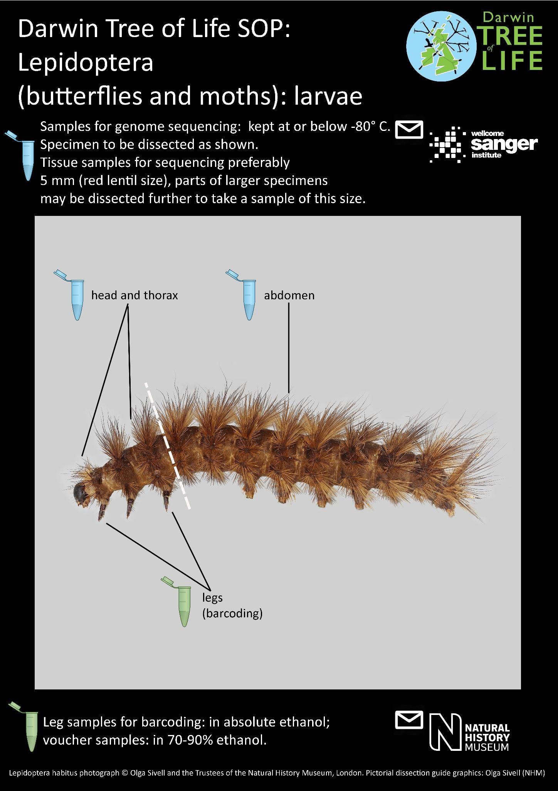

Figure 25: Coleoptera larvae

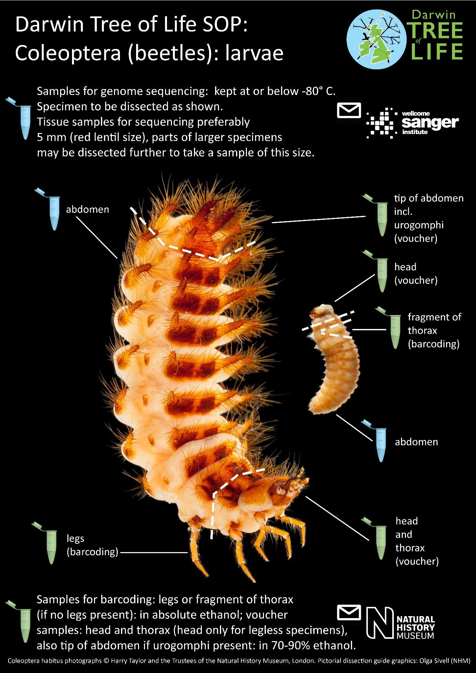

Figure 26: Trichoptera larvae

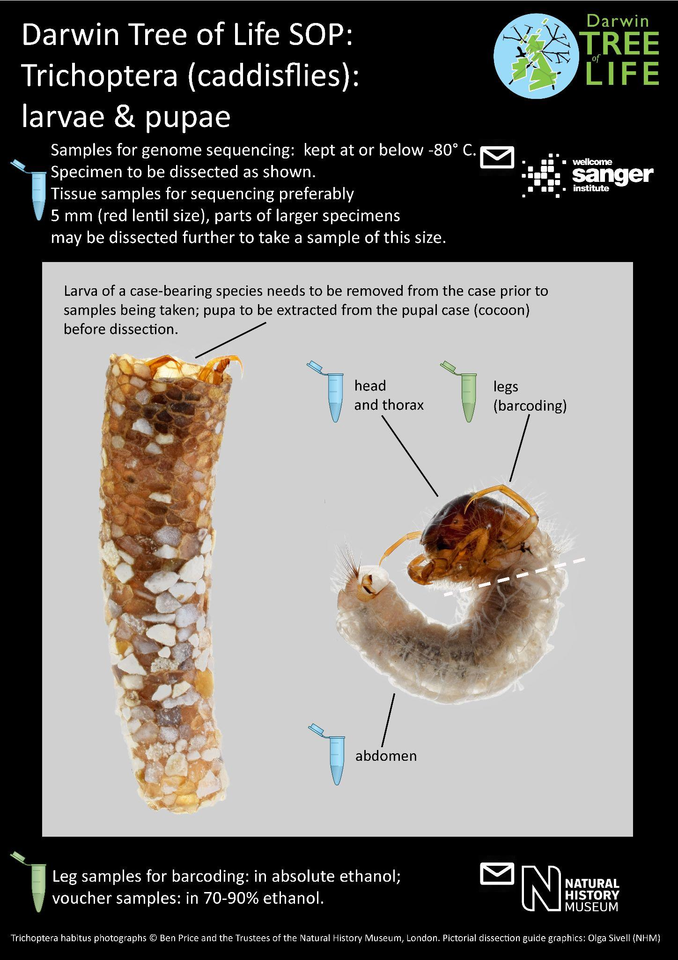

Figure 27: Diptera larvae

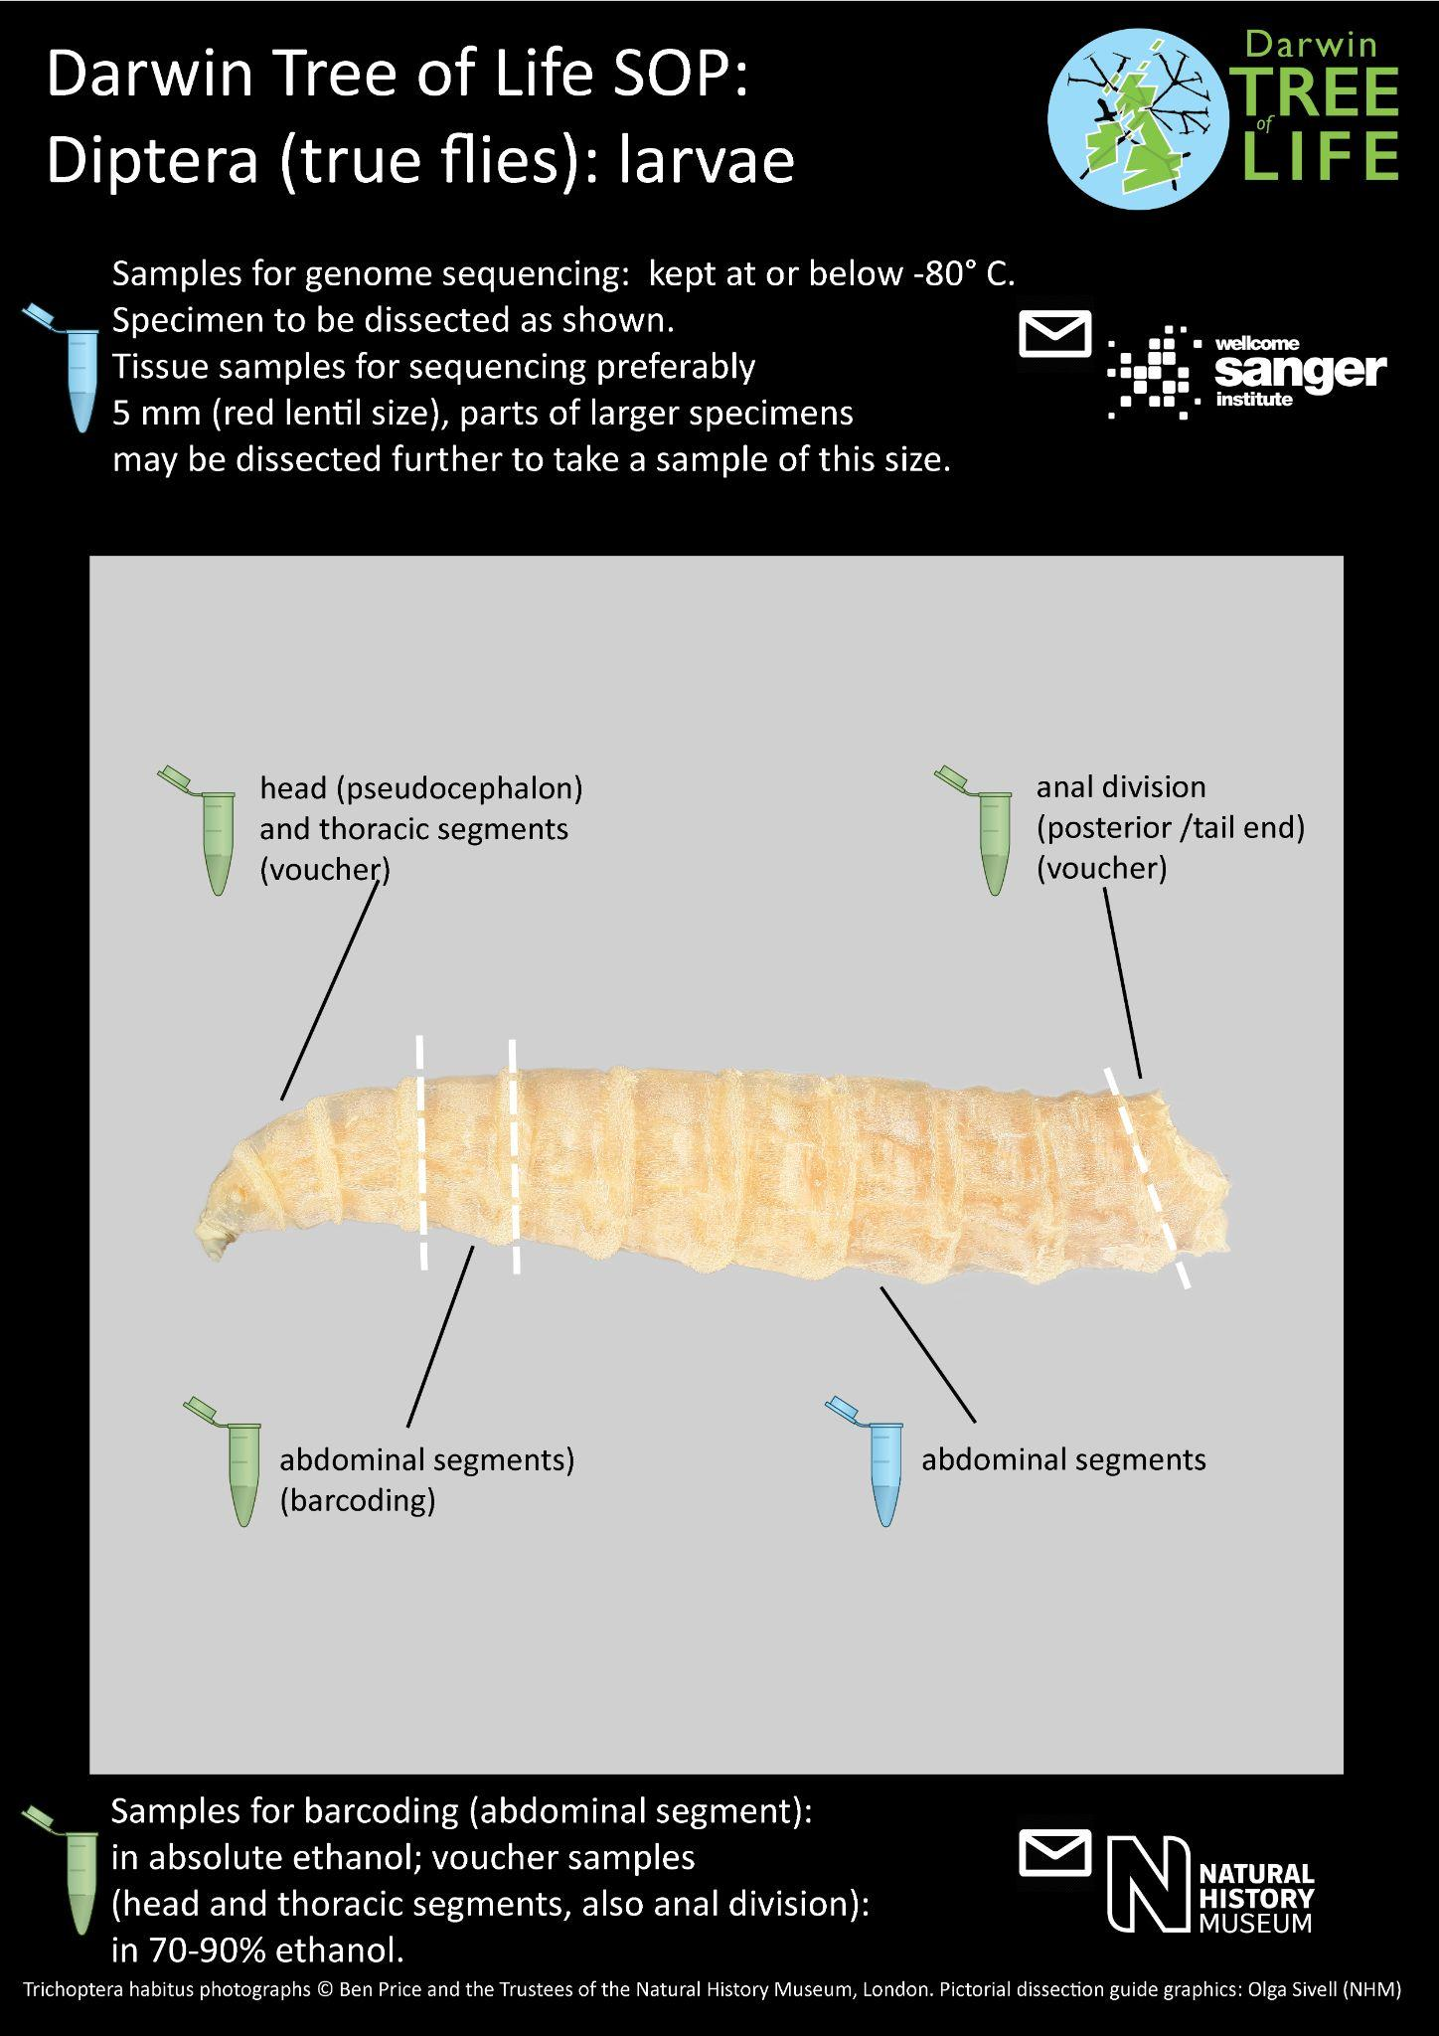

Figure 28: Megaloptera larvae
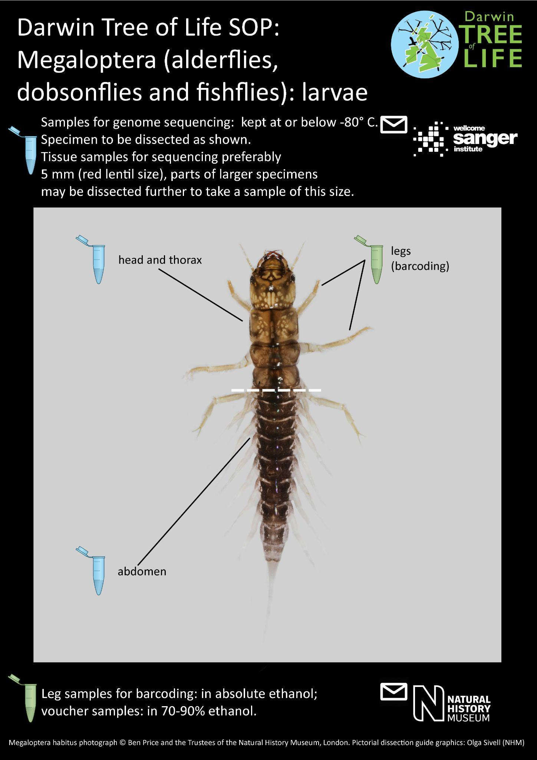

TSS3: Taxon group: Terrestrial Arthropoda smaller than 5mm

Note: For genome sequencing, anything smaller than a lentil (5mm), or estimated to be around 5mm, should be frozen whole (live) after photography. There are numerous species that fit under this category. Tissue or extract from Sanger will be used for DNA barcoding.

Including: Arachnidae (especially Acari, Pseudoscorpiones), Amphipoda (under 10mm), Collembola, Diplura, Protura, Symphyla, Pauropoda and terrestrial insects (incl. terrestrial and aquatic life stages of freshwater taxa) smaller than 5mm: Archaeognatha, Phthiraptera, Psocoptera, Siphonaptera, Strepsiptera, Thysanoptera, Zygentoma, also small species from remaining orders, e.g. Blattodea (‘Isoptera’), Coleoptera, Diptera, Hymenoptera, Lepidoptera, Mecoptera (Boreidae), Hemiptera.

Detail | Select
Field sampling:
1. Environment to be sampled: | Terrestrial and freshwater.
2. Trap/method of sampling: | Bulk capture and single specimen targeted (up to five specimens of the same species collected if possible). If aquatic, sorted in a tray of water with specimens still alive.
1.& 2. Additional comments: | Each specimen, regardless of species, must have its own relevant unique identifier (e.g. QR code) which will be attached to any subsequent tubes, genome or barcoding results.

For genome sequencing
Tissue preparation:
3. Can specimens be sampled and frozen while still alive? | Y
3. Additional comments: | Must be frozen at -80˚C or lower. Specimens to be identified (where possible up to genus as a minimum) and photographed prior to tissue preparation for genome sequencing.  Freshwater specimens should be imaged live, in water.
Photography:
4. Photography appropriate for taxon: | Whole body, as appropriate.
4. Additional comments: | The image should be taken in the highest quality resolution - macro lens recommended.  Photograph to include a unique identifier (e.g. QR code, NHMUK barcode) where possible.
Dissection: | Ensure all tube barcodes are linked with the original specimen
5. Specimen is larger than a lentil (ca. 5 mm) | N
5.1 Estimated number of sections (per specimen) dissected for genome sequencing (into separate FluidX tubes): | NA
5, 5.1. Additional comments: | Whole specimen to be put in one tube and frozen.  Any corresponding tube IDs need to be linked with the unique specimen identifier.
Storage of frozen tissue:
6. All prepared tubes with frozen dissected tissue sent to? | The Wellcome Sanger Institute. The tissue or extract from genome sequencing at Sanger will also be used for DNA barcoding.
Storage of voucher:
7. Sent to/Kept at NHM as voucher? | After whole genome sequencing; the DNA extract should be sent to NHM, to act as a voucher. The photograph will also act as a voucher if the whole specimen was destructively sampled.
8. Rest of specimen (voucher) curated in | if any part of the specimen was preserved; stored in a vial with 70- 90% ethanol.
9. Preparation technique | Wet (vial with 70- 90% ethanol).
SOP checked by expert? | Y

